 | Industrial Revolution |  |  | 
 | Year Group: 6 | Subject Focus: History | Term: Autumn 1
Key facts  - Leeds is famous for producing and trading wool in the 17th and 18th centuries.  - During the Industrial Revolution, Leeds was a major engineering centre. Holbeck and Hunslet were particularly important areas for engineering.  - Leeds built up from a small manorial borough in the 13th century.  - Leeds sits on the River Aire and the Leeds and Liverpool Canal.  - Around 800,000 people live in Leeds.  - Armley Mills was once the largest woollen mill in the world.  - The Leeds and Liverpool Canal was built between 1770 and 1816 to connect the big industrial towns of Yorkshire to the port of Liverpool and the market in America. |  | 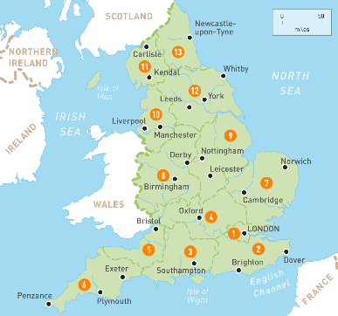  Leeds played an important part in the Industrial Revolution.  Leeds is now a rich industrial city and an important financial area outside of London.  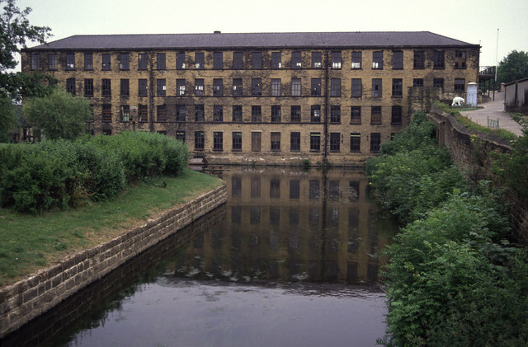 | Key words:  industrial an area characterised by industry.  revolution in favour of a new system  locomotive a powered railway vehicle for pulling trains  invention creating something based on an area of need.  Victorian era the period between 1820 and 1914  mass produce manufactured in large quantities by a mechanical process  mechanise to introduce machines  trade buying and selling of goods.  industry making of goods by using machines or factories.  urbanisation the growth of cities due to movement of people.
Did you know?
- Leeds was originally known as Loidis by the Anglo-Saxons.
- People from Leeds are known as Loiners.
- The oldest building in Leeds is Lambert’s Yard on Lower Briggate.
- It is believed that the Vikings came to Leeds and that there was a Viking settlement in Armley, although no evidence has been found.
 |  | Exciting books/ web links:  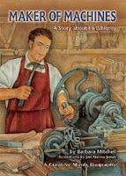  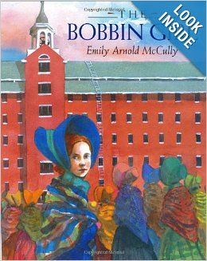  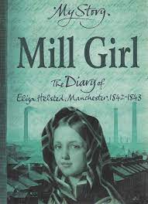  https://www.bbc.co.uk/bitesize/topics/zxwxvcw/articles/zntn6v4 | Parents as partners:  - Encourage your child to create some amazing fact cards about the Industrial Revolution.  - Together, investigate Leeds as a centre of engineering.  - Create a word search or crossword about Leeds and the Industrial Revolution.  - Discover which buildings in Leeds were woollen mills?

