Year 6 Newsletter (Spring 2)

Welcome back to Blackman Class in year 6! As we continue on our journey through year 6, we look forward to lots of learning and exciting projects this half term.
Our learning journey
This half term we will be again focusing on geography in our topic lessons. We will investigate trade links and why Fairtrade is so important to the global economy. We will also be linking our DT lessons to this topic by using Fairtrade products in our food technology lessons. Please see the knowledge organiser to find out more.   | In Science, we are continuing to work on  living things and their habitats. We will learn all about how to use and create classification keys. During these lessons, we will think about how the different plants and animals can be categorised.  We will then focus on Evolution and Inheritance.  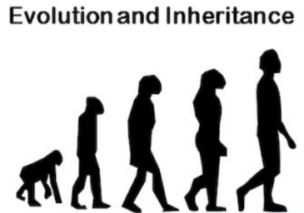 | In our Maths lessons we will continue to work on our arithmetic skills in preparation for our upcoming tests. This will include revising fractions, decimals and percentages.  We will also be focusing on, perimeter, area, volume, angles and algebra this half term.  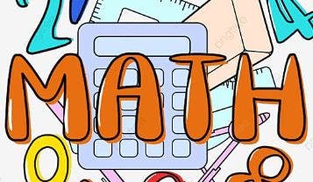 | In English we will focus on formal writing by completing a balanced argument. We will then write our own poetry based on The Jabberwocky by Lewis Carroll.  In reading we will focus on the novel: Skellig.  We will also be working on our spelling, punctuation and grammar as well as developing our comprehension skills throughout the half term.  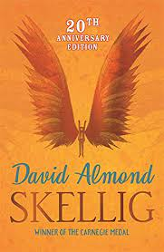

Diary Dates:  Reminder that our residential to Liverpool will take place on Mon 24th June – Wed 26th June. Please see parent pay regarding payments.  PE will continue to be on a Monday and Thursday. The children need to come to school in their uniform and change into their PE kits just before the lesson.  The year 6 SAT tests will take place from Mon 13th May – Thu 16th May. | Class routines:  - The children are expected to read at home every night and have their reading record signed by an adult. This is the single most useful thing that parents can do to support their children’s learning.  - Each Friday, the children will complete a spelling and mental maths test. The spellings and maths focus will be sent home on a Friday, ready to learn for the following Friday. Please work on these at home.  - Please see the class website page to help prepare the children for our upcoming year 6 tests. There are useful links for the children to revise at home.  - Pupils should also continue to log onto TTRockstars to improve their times tables knowledge.
Finally, please remember to log onto the class page on the school website to keep up to date with our latest news: https://www.crossgatesprimary.co.uk/class-pages/ or by accessing the school twitter page.
Miss Wilson & Miss Cantwell

