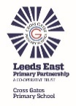 | Fairtrade
 | Year Group: 6 | Subject Focus: Geography | Term: Spring 2
Key facts  - The UK trades a lot of goods and services.  - Some of the goods the UK exports are: scrap iron, tartan kilts, medicines, aircraft parts, cars, computers, oil and gas.  - Some of the goods the UK imports are: coffee beans, bananas, medicines, aircraft parts, cars, computers, oil and gas  - There are lots of steps in the trade process but people involved are not always paid equally or fairly.  - Fair trade exists to make sure that people are not exploited. Look out for the fair trade logo when buying things so that you know that people have been paid fairly for their work |  | Fairtrade Logo: Look out for this symbol on products bought in the UK.    Global Trade: Uk imports and exports  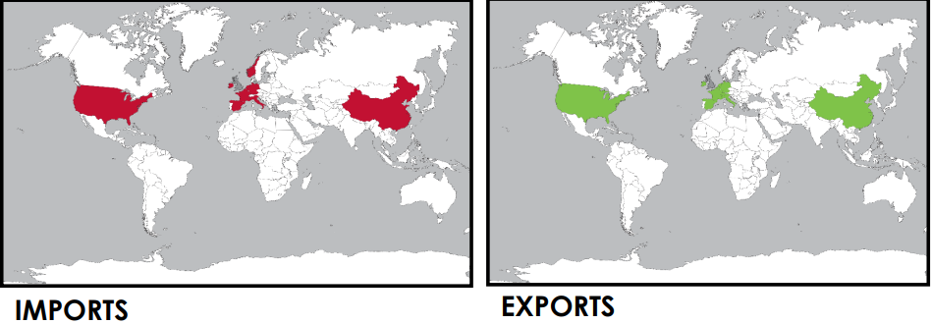 | Key words:  Economy The word used to explain how money is made and spent in particular area. This could be within a country or across the world.  Ethical Describing a person or behaviour as morally right (e.g. truthful / fair / honest).  Export Goods and services made in the UK and sold to another country  Fairtrade A way of buying goods designed to make sure that the producers of these goods in developing countries are paid a fair and stable price for the goods that we buy from them  Global Around the world  Import Goods and services purchased from one country and brought into the UK  Poverty Not having enough money for basic needs such as food, water and shelter).  Produce To create, manufacture or cultivate (farm) something.  Sustainable The idea that humans must look after the environment in a way that ensures there will be enough resources left for future generations.  Trade Buying and selling goods and services.
Did you know?
- Fairtrade means that farmers are paid a fair minimum price for their produce
- The Fairtrade Premium provides extra money to develop farmer’s communities and protect their environment.
- Having a minimum price means farm owners can plan for the future because they have a regular income.
- Women are able to become involved and have a say. Previously, it would have been only the men allowed to do this.
- Fairtrade supports 1.65 million farmers and farm workers in 74 countries.
- When we buy Fairtrade products, we are helping farmers in poorer countries live better lives.
 |  | Exciting books/ web links:  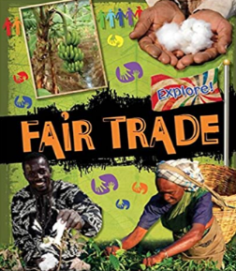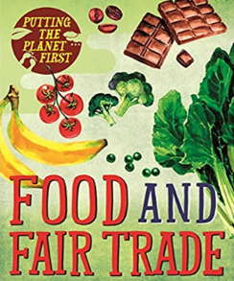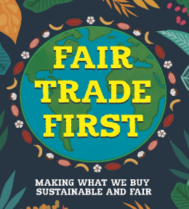  https://schools.fairtrade.org.uk/  https://www.theschoolrun.com/homework-help/fair-trade  https://cafod.org.uk/education/education-resources/fairtrade-school-resources | Parents as partners:  - When shopping, look out for the Fairtrade logo.  - Create a word search or crossword linked to Fairtrade.  - Play games (such as Go Fish or Happy Families) that involve trade.  - Use PurpleMash to investigate Trade / Fairtrade.  - Research the trade links within the UK.  - Create PowerPoints or posters showing what you know about Trade / Fairtrade.  - Encourage your child to create some amazing fact cards about the fair trade.  - Bake and create healthy meals using Fairtrade products.

