 | The importance of rainforests. |  |  | 
 | Year Group: 6 | Subject Focus: Geography | Term: Spring 1and 2
Key facts  - Rainforests are essential to life on earth.  - Tropical rainforest are home to more than half of the world’s animal species.  - Rainforests cover less than 3% of the earth.  - Rainforests play an essential part in maintaining the earth’s limited supply of fresh water.  - Plants from the rainforests are used in some of the world’s most important life-saving medicines.  - A piece of rainforest the size of 40 football pitches disappears every minute.  - 1 out of 4 people worldwide depend on the rainforests for their livelihood. |  | 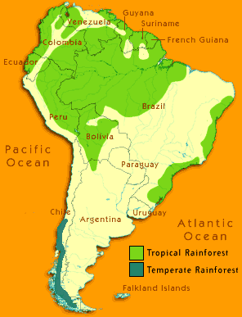  The Amazon Rainforest is  the largest rainforest in  the world.  It spans more than two  million square miles in  northern South America.  There are several rainforests across the world.  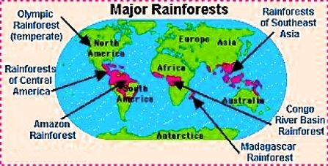 | Key words:  Biodiversity The wide variety of living things on the earth  Biome Areas of the planet with a similar climate and landscape, where similar animals and plants live.  Canopy layer The tallest layer of trees in a rainforest  Climate The weather and temperature usually found in an area over a long period of time  Deforestation The destruction of trees over a large area  Emergent layer Very tall rainforest trees that rise above all the other trees around them  Forest floor The lowest layer in the rainforest where it is dark, damp and hot!  Indigenous A living thing that belongs naturally to an area  rainforest A dense forest rich in biodiversity, found typically in tropical areas with consistently heavy rainfall.  Understorey layer The layer of vegetation in a forest which is below the canopy but off the ground
Did you know?
- The Amazon Rainforest is estimated to have 390 billion trees and 2 and a half million species of insects.
- When a 35 metre tree is felled, it can crush up to 17 smaller trees as it crashes to the ground.
- Beneath rainforests there often lies a wealth of natural resources in the form of mineral and gold deposits.
- The destruction of the rainforest could affect the world's climate.
 |  | Exciting books/ web links:  http://ypte.org.uk/factsheets/rainforests/introduction  https://www.rainforestconcern.org/  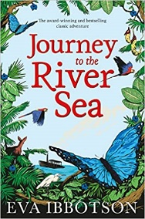  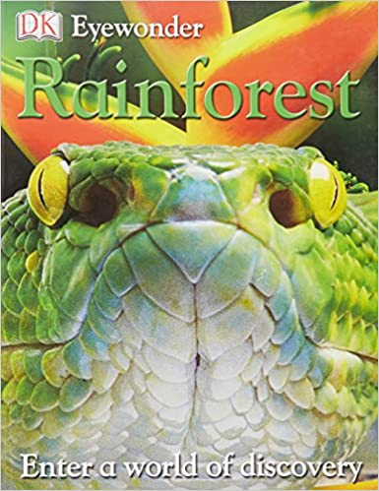   | Parents as partners:  - Encourage your child to create some amazing fact cards about the rainforests.  - Together, make a poster comparing the Amazon Rainforest and Sherwood Forest.  - Create a word search or crossword about the rainforests.  - If you could visit a rainforest, what would you do? Look on line and create an itinerary for a weekend visit. How many different animals could you see?  - Find out about the tribes of the Amazon Rainforest.

