 | Living things and their habitats
 | Year Group: 6 | Subject Focus: Science | Term: Spring 1&2
Key facts  - Animals can be grouped into carnivores, herbivores and omnivores. They can also be grouped into vertebrates and invertebrates.  - Organisms can be classified and we can use a classification key to identify them.  - The categories for classifying vertebrates are: Reptiles, Fish, Amphibians, Birds and Mammals.  - Living things depend on each other in order to survive.  - Environments and habitats are changing, which impacts how well animals thrive.  - Food chains demonstrate the direction in which energy travels.  - Organisms have adapted and evolved over time.  Did you know?  - A classification key is a tool that is used to group living things to help us identify them using recognisable characteristics. In 1735, Swedish Scientist Carl Linnaeus first published a system for classifying all living things. An adapted version of this system is still used today: The Linnaeus System.  - Microorganisms Are very tiny living things. They are not visible to the naked eye so a microscope is needed to see them. Microorganisms are found all around us, they can live in our bodies, in water, in the air and on the objects around us.  - Examples of microorganisms include dust mites, bacteria and fungi, such as mould. |  | 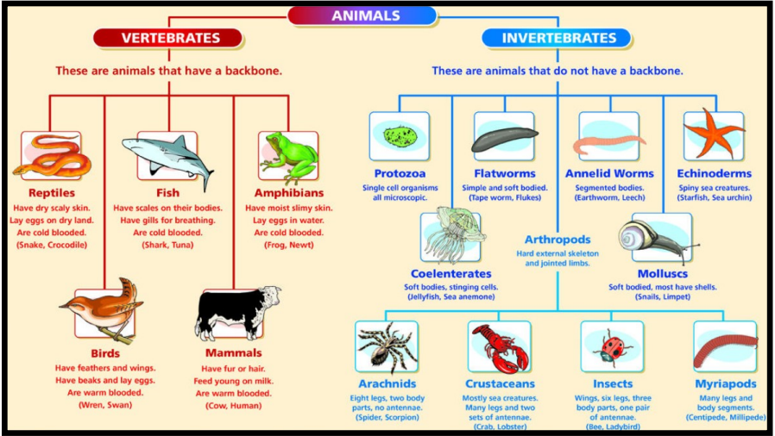  Exciting books / web links:  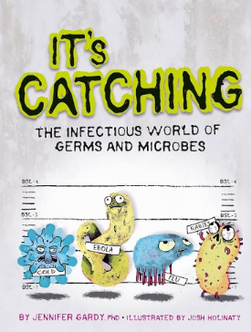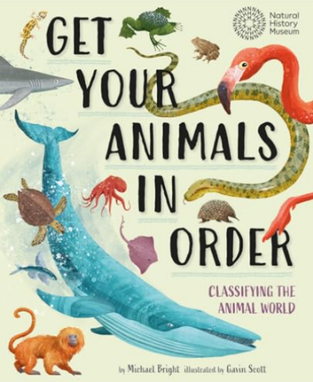  https://www.bbc.co.uk/bitesize/articles/zyq9r2p#z7rhhcw  https://www.bbc.co.uk/bitesize/articles/zsgtrwx  https://www.stem.org.uk/resources/community/collection/11373/micro-organisms | Key words:  Amphibians A cold-blooded vertebrate animal that is born in water and breathes with gills.  Birds A warm-blooded, egg-laying vertebrate animal. Has feathers, wings, a beak - can usually fly.  Classification The arrangement of organisms into orderly groups based on their similarities and presumed evolutionary relationships.  Fish An aquatic vertebrate animal that has gills but lack limbs with digits, like fingers or toes.  Invertebrates Does not have a backbone. 97% of creatures belong to this group.  Mammals A warm-blooded vertebrate animal. Has hair or fur, females secrete milk to feed their offspring, and (typically) give birth to live young.  Micro-organism An organism which is microscopic, making it too small to be seen by the human eye.  Organism An individual animal, plant or single celled life form.  Reptiles An animal that has cold blood, that lays eggs, and that has a body covered with scales or hard parts.  Vertebrates An animal that has a backbone.  Parents as partners:  - Glitter Germ Investigation https://www.livinglifeandlearning.com/glitter-germ-experiment.html  - Experiments to do at home  https://learning-center.homesciencetools.com/article/bacteria-experiment-guide/  - Create an animal fact file showing how they can be classified.  - Create a PowerPoint all about classifying animals and/or microorganisms.

