 | Animals including Humans
 | Year Group: 6 | Subject Focus: Science | Term: Autumn 2
Key facts  - A healthy, balanced diet can have a huge effect on a person’s health. People who eat the right balance of fresh, healthy foods are less prone to chronic illnesses and diseases.  - As we exercise, our muscles need more oxygen. So, we breathe quicker, helping our lungs to take in more oxygen. Our heart needs to pump blood more quickly to get all of the oxygen around the body. In order to do this, our heart rate increases.  - A drug is a chemical has an effect on your body. Some dugs are prescribed by doctors to make people healthy. Other, illegal drugs can have a dangerous effect on our health. |  | 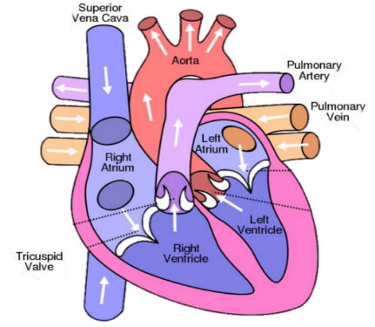  The circulatory system is centred on the heart, an organ that works constantly to pump blood around the body.  The heart is made up of four sections called chambers. There are two sides to the heart (right and left) each of which have an atrium (at the top) and a ventricle (at the bottom).    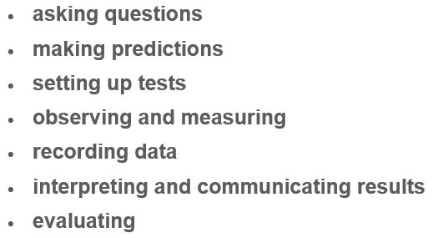 | Key words:  artery blood vessels that deliver oxygen-rich blood from the heart to the tissues of the body  blood the red liquid that circulates in the arteries and veins of humans and other vertebrate animals, carrying oxygen to and carbon dioxide from the tissues of the body  blood vessel part of the circulatory system that carries blood (a vein, artery or capillary)  carbon dioxide a gas produced by animals and people breathing out  circulatory the system responsible for circulating blood through the body, that supplies nutrients and oxygen to the body and removes waste products such as carbon dioxide.  heart muscular organ that pumps blood through the body  lungs two organs inside your chest which fill with air when you breathe in. They oxygenate the blood and remove carbon dioxide from it.  oxygen a chemical element which animals need to survive  respire breathing, inhaling and exhaling air  vein blood vessels that carry blood towards the heart
Did you know?
- Regular exercise helps our bones and muscles to become stronger. It also helps the heart and lungs to become healthier.
- Alcohol is a depressant. Alcohol can cause damage to the liver and brain. Cigarettes contain nicotine and cause damage to the lungs and heart.
- Louis Washkansky received the first human heart transplant in 1967, South Africa.
- If you linked up all of the body’s blood vessels, including arteries, capillaries and veins, they would measure over 60,000 miles.
 |  | Exciting books / web links:  https://www.bbc.co.uk/bitesize/clips/z9dg9j6  https://www.stem.org.uk/resources/community/collection/13109/year-6-animals-including-humans  https://www.hamilton-trust.org.uk/science/year-6-science/art-being-human/  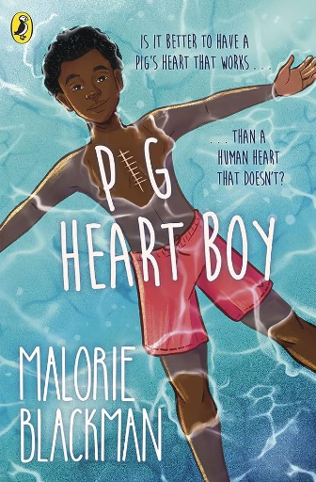 | Parents as partners:  - Monitor your heart rate regularly and describe how it changes over the course of a day.  - Research how your diet differs from your favourite sportsperson.  - Create a fact file about Santorio Santorio or Sir Richard Doll.  - Find out what would happen to our bodies if we went without certain foods/nutrients.  - Design a healthy snack and list the nutrients it contains.  - Create a poster raising awareness of the impact of drugs and to live a healthier lifestyle.

