 | Rivers
 | Year Group: 6 | Subject Focus: Geography | Term: Autumn 2
Key facts  - The River Aire is a major river in Yorkshire.  - The source of the River Aire is in the Yorkshire Dales near Malham.  - The River Aire is 148Km long.  - During the Industrial Revolution , the River Aire was seriously polluted along most of its length.  - There are now otters and other wildlife living in the river.  - You can row and canoe on the river.  - You can walk along the banks of the river in Leeds and at other parts along its course. |  | 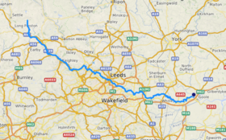  The upper course: rain falling on higher ground collects in channels and flows downwards forming a stream. This increases in size and forms a river. The river flows quickly here and runs through steep-sided valleys. Features - waterfalls  The middle course: fast lowing water causes erosion making the river deeper and wider. Features – meanders.  The lower course: rivers flow with less force due to being on flat land. River deposits the eroded material that has been carried. River banks have shallower sides. Features – floodplains, deltas, estuaries.  Erosion involves the wearing away of rock. Rivers erode the riverbank and bed. Material carried by the river is broken down into small, rounder, and smoother pieces.  Transportation is when material is picked up by the river and moved downstream.  Deposition is when the river drops its load. This is usually when the river loses energy. | Key words:  Channel The course in the ground which a river flows through.  Confluence Occurs when two or more flowing bodies of water join together to form a single channel.  Estuary Where rivers and streams meet the sea.  Floodplains This is a large, flat area of land that is formed by erosion and deposition.  Meander A bend in the river.  Mouth Where a river flows into the sea, a lake or any other larger body of water.  Oxbow Lake Is formed when a wide meander of a river is cut off, creating a free-standing, U-shaped body of water.  River Deltas A wetland area that forms as river waters empty into a larger body of water.  Source Where the river begins.  Tributary a stream or river that flows into and joins a main river.
Did you know?
- There is evidence of the River Aire from about 959AD.
- Part of the River Aire is canalised and is called the Aire and Calder Navigation.
- Until the 17th century, the River Aire was a drinking source for the people of Leeds.
- The River Aire is between 0.29m and 2.70m deep.
- The River Aire last flooded in February 2020.
 |  | Exciting books/ web links:  https://www.bbc.co.uk/teach/class-clips-video/geography-ks1--ks2-rivers/z6qsf4j  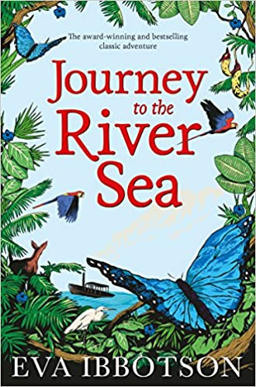  https://www.rgs.org/schools/teaching-resources/rivers-(1)/journey-of-a-river/  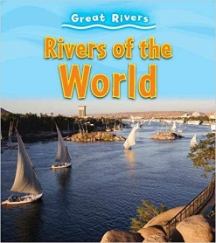  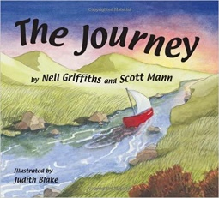 | Parents as partners:  - Encourage your child to discover interesting facts about the River Aire.  - Together, visit various parts of the River Aire in Leeds.  - Create a word search or crossword about Leeds and the River Aire.  - Discover some interesting facts about the River Aire.

