Year 4 Newsletter (Summer 2)

Welcome back to Year 4 - Fine class! I hope you had a lovely half term break holiday. As we embark into our final half term, get ready for a wealth of learning experiences and engaging projects.
Our learning journey
Our Geography unit for this half term will be exploring Yorkshire.  We will name and locate counties of the UK, understanding that Yorkshire is made up on 4 counties. The children will also locate some of the main towns and cities in Yorkshire. We will locate and name the rivers and hills in Yorkshire.  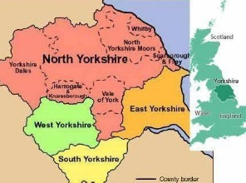 | In Science, we will we will focus on animals including humans.  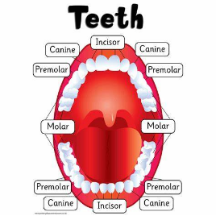  The children will name the different types of teeth found in humans and explain their functions. They will be able to explain what tooth decay is and how to look after their teeth. The children will also be able to describe the simple functions of the basic parts of the digestive system in humans. Finally, we will look at a variety of food chains, identifying producers, predators and prey. | In our Maths lessons, we will focus on angles, understanding angles as turns and identifying different angles. We will then look at the angles in different triangles, quadrilaterals and polygons as well as lines of symmetry. We will then look at line graphs, interpreting key information as well as drawing our own. Finally, we will look at position and direction, plotting coordinates and drawing 2D shapes on a grid.  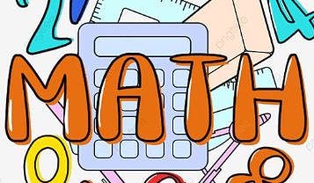 | In English, we will begin by exploring two different poems ‘From a railway carriage’ by Robert Louis Stevenson and ‘Night Mail’ by W.H. Auden. We will then read the Varmints and compose a narrative based on the structure of this story. Finally, we will write a persuasive tourist information brochure about visiting Yorkshire focusing on different persuasive techniques to entice the reader.  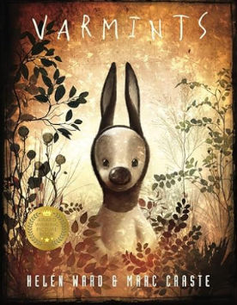

Diary Dates:  PE will take place on a Tuesday and swimming will take place on Thursday. The children need to come to school in their uniform on Tuesdays and bring the full PE kit. They will also need a water bottle.  On Friday 7th June – Swift Parade.  On Wednesday 19th June – Sports Day. | Class routines:  - The children are expected to read at home every night. Reading records and books should be brought to school every day so that a member of staff can read with them in school. These reading books will be changed on a Friday if the reading record has been signed.  - Each Friday, the children will complete a spelling quiz. The spellings focus will be sent home on a Friday, ready to learn for the following Friday. The children will need to practise these at home (and at school) on a regular basis.  - Pupils should continue to log onto TTRockstars to improve their times tables knowledge. This is constantly monitored as well as accessed in class to prepare the children for their Multiplication Times Table Check in June.
Finally, please remember to log onto the class page on the school website to keep up to date with our latest news: https://www.crossgatesprimary.co.uk/class-pages/ or by accessing the school twitter page.
Miss Beaumont

