Year 4 Newsletter (Summer 2)

Welcome back to Year 4 - Fine class! I hope you had a relaxing half term break. As we embark into our final half term, get ready for a wealth of learning experiences and engaging projects.
Our learning journey
Our Geography unit for this half term will be exploring Yorkshire.  We will name and locate counties of the UK, understanding that Yorkshire is made up of 4 counties. The children will also locate some of the main towns and cities in Yorkshire. We will locate and name the rivers and hills in Yorkshire.  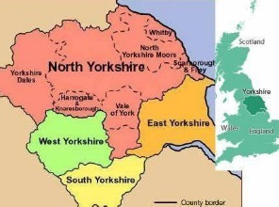 | In Science, we will focus on living things and their habitats.  We will be able to name the seven things that all living things do, we call these life processes. We will also explore how to group and classify living things. We can group animals into groups based on their characteristics, what they eat and based on whether they have a backbone.  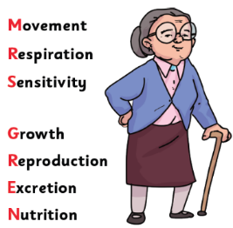  Finally, we will discuss the effect that human activity has on the environment and some of the dangers this can have on living things. | In our Maths lessons, we will focus on angles, understanding angles as turns and identifying different angles. We will then look at the angles in different triangles, quadrilaterals and polygons as well as lines of symmetry. We will then look at line graphs, interpreting key information as well as drawing our own. Finally, we will look at position and direction, plotting coordinates and drawing 2D shapes on a grid.  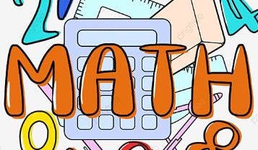 | In English, we will begin by reading the Varmints and composing a narrative based on the structure of this story. We will then write a persuasive tourist information brochure about visiting Yorkshire focusing on different persuasive techniques to entice the reader. Finally, we will explore poetry from art by looking at the View of Poolbeg Lighthouse by William Sadler the Younger.  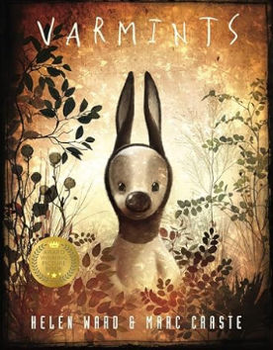

Diary Dates:  PE will take place on a Wednesday and Thursday. The children need to come to school in their uniform on these days and bring the full PE kit. They will also need a water bottle.  Monday 2nd – Friday 13th June – Y4 Multiplication Times Table Test  Wednesday 18th June – Sports Day  Wednesday 25th June – Hockey Tournament | Class routines:  - The children are expected to read at home every night. Reading records and books should be brought to school every day so that a member of staff can read with them in school. These reading books will be changed on a Friday if the reading record has been signed.  - Each Friday, the children will complete a spelling quiz. The spellings focus will be sent home on a Friday, ready to learn for the following Friday. The children will need to practise these at home (and at school) on a regular basis.  - Pupils should continue to log onto TTRockstars to improve their times tables knowledge. This is constantly monitored as well as accessed in class to prepare the children for their Multiplication Times Table Check in June.
Finally, please remember to log onto the class page on the school website to keep up to date with our latest news: https://www.crossgatesprimary.co.uk/class-pages/ or by accessing the school twitter page.
Miss Beaumont and Mrs Middleton

