Year 4 Newsletter (Summer 1)

Welcome back to Year 4 - Fine class! I hope you had a lovely Easter holiday. As we embark into our final term, get ready for a wealth of learning experiences and engaging projects.
Our learning journey
Our History unit for this half term will be exploring The Maya  We will develop our understanding of a non-European society that provides contrasts with British history. We will learn who the Maya were, how they advanced society and their major achievements. We will also look at how these accomplishments have impacted on our lives today.  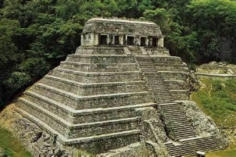 | In Science, we will we will continue to focus on sound.  The children will receive a workshop on the Science of Sound by an external specialist where they will participate in lots of different experiments to fully understand how sound is made, the difference between high, low, loud and quiet and the kinds of materials that conduct and amplify sounds.   | In our Maths lessons, we will focus on decimals, understanding how to make a whole with tenths and hundredths focusing on number bonds to support learning. We will also explore how to partition decimals and to understand the value of each digit in order to compare and order them. We will then finish the half term learning about calculating money and converting between pound and pence as well as exploring how to tell the time.  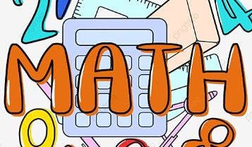 | In English, we will begin by exploring Mayan based poetry – Songs of Dzitbalche.  We will then read the story of the Hero Twins. We will explore key genre and grammar features of a diary entry to convert the narrative into a recount, writing from the perspective of a Mayan citizen. Finally, we will write a Mayan fact file, linking to our learning on the Maya in history with a focus on formal writing.  

Diary Dates:  PE will take place on a Tuesday and swimming will take place on Thursday. The children need to come to school in their uniform on Tuesdays and bring the full PE kit. They will also need a water bottle.  On Friday 19th April, we will have a Science of Sound workshop.  Every Wednesday afternoon, we will be completing an Art project with an external specialist, linking to the Swift Project. | Class routines:  - The children are expected to read at home every night. Reading records and books should be brought to school every day so that a member of staff can read with them in school. These reading books will be changed on a Friday if the reading record has been signed.  - Each Friday, the children will complete a spelling quiz. The spellings focus will be sent home on a Friday, ready to learn for the following Friday. The children will need to practise these at home (and at school) on a regular basis.  - Pupils should continue to log onto TTRockstars to improve their times tables knowledge. This is constantly monitored as well as accessed in class to prepare the children for their Multiplication Times Table Check in June.
Finally, please remember to log onto the class page on the school website to keep up to date with our latest news: https://www.crossgatesprimary.co.uk/class-pages/ or by accessing the school twitter page.
Miss Beaumont

