Year 4 Newsletter (Summer 1)

Welcome back to Year 4 - Fine class! I hope you had a lovely Easter holiday. As we embark into our final term, get ready for a wealth of learning experiences and engaging projects.
Our learning journey
Our History unit for this half term will be exploring The Maya.  We will develop our understanding of a non-European society that provides contrasts with British history. We will learn who the Maya were, how they advanced society and their major achievements. We will also look at how these accomplishments have impacted on our lives today.  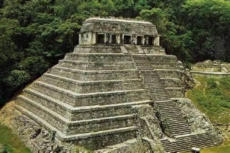 | In Science, we will we will focus on animals including humans.  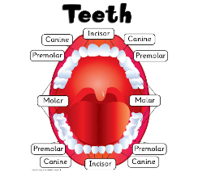  The children will explore the different types of teeth found in humans and explain their functions. We will gain an understanding of what tooth decay is and how to look after our teeth. We will then describe the simple functions of the basic parts of the digestive system in humans. | In our Maths lessons, we will continue to focus on decimals: understanding how to make a whole with tenths and hundredths using our number bonds to support learning. We will also explore how to partition decimals and to understand the value of each digit in order to compare and order them. We will then finish the half term learning about calculating money and converting between pound and pence as well as exploring how to tell the time.  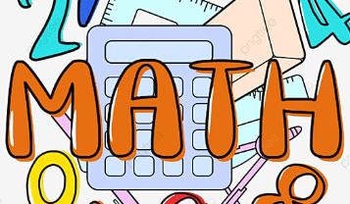 | In English, we will begin by exploring performance poetry: performing a poem with effective use of sound effects, pace parts and other techniques used for impact.  We will then write a Mayan fact file, linking to our learning on the Maya in history with a focus on formal writing. Finally, we will explore the key genre and grammar features of a diary entry to write from the perspective of a Mayan citizen.  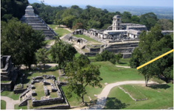

Diary Dates:  PE will take place on a Wednesday and Thursday. The children need to come to school in their uniform on these days and bring the full PE kit. They will also need a water bottle.  On Thursday 24th April, it is the KS2 Easter Disco at 4:45 – 5:45.  On Monday 2nd June – Friday 13th June, it is the Year 4 Multiplication Times Table Check. | Class routines:  - The children are expected to read at home every night. Reading records and books should be brought to school every day so that a member of staff can read with them in school. These reading books will be changed on a Friday if the reading record has been signed.  - Each Friday, the children will complete a spelling quiz. The spellings focus will be sent home on a Friday, ready to learn for the following Friday. The children will need to practise these at home (and at school) on a regular basis.  - Pupils should continue to log onto TTRockstars to improve their times tables knowledge. This is constantly monitored as well as accessed in class to prepare the children for their Multiplication Times Table Check in June.
Finally, please remember to log onto the class page on the school website to keep up to date with our latest news: https://www.crossgatesprimary.co.uk/class-pages/ or by accessing the school twitter page.
Miss Beaumont and Mrs Middleton

