Year 4 Newsletter (Autumn 2)

Welcome back to Year 4, Fine class! As we embark on the second half of the term, get ready for a wealth of learning experiences and engaging projects.
Our learning journey
Our Geography unit for this half term will be exploring Greece.  We will develop our understanding of where Greece is and look closely at the human and physical features of this country. We will then draw comparisons between a region in Greece with Leeds.   | In Science, we will continue our learning on electricity before moving on to states of matters. We will learn how to compare and group materials together, according to whether they are solids, liquids or gases and observe that some materials change state when they are heated or cooled.  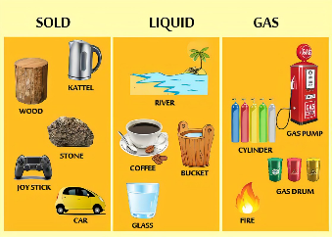 | In our Maths lessons, we will continue our work on multiplication and division methods with time to consolidate our autumn learning. In order to be successful in these lessons, it is essential that the children continue to work on their times tables and speed up their recall of times table and division facts.  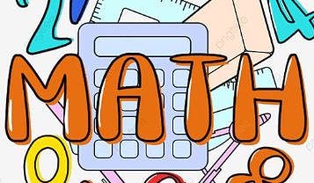 | In English, we will be reading, reciting and enjoying simple riddles before writing our own. We will then focus on the text ‘I was a Rat!’ to write a narrative, exploring the use of description and setting. To finish, we will write a non-chronological report about life in modern Greece showcasing our geography learning.  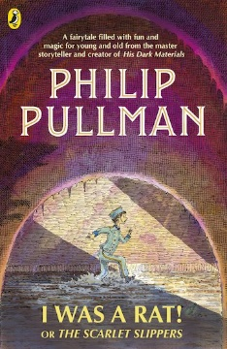

Diary Dates:  PE will take place on a Tuesday and swimming will take place on Thursday. The children need to come to school in their uniform on Tuesdays and bring the full PE kit. They will also need a water bottle.  The whole school will be going on a visit to the theatre on Tuesday 5th December; we will be watching Oliver Twist.  Our residential to Herd Farm will take place on Wednesday 20th – Friday 22nd December. | Class routines:  - The children are expected to read at home every night. Reading records and books should be brought to school every day so that a member of staff can read with them in school. These reading books will be changed on a Friday if the reading record has been signed.  - Each Friday, the children will complete a spelling quiz. The spellings focus will be sent home on a Friday, ready to learn for the following Friday. The children will need to practise these at home (and at school) on a regular basis.  - Pupils should continue to log onto TTRockstars to improve their times tables knowledge. This is constantly monitored as well as accessed in class to prepare the children for their Multiplication Times Table Check in June.
Finally, please remember to log onto the class page on the school website to keep up to date with our latest news: https://www.crossgatesprimary.co.uk/class-pages/ or by accessing the school twitter page.
Miss Beaumont & Mrs Pearson

