Year 4 Newsletter (Autumn 2)

Welcome back to Year 4, Fine class! As we embark on the second half of the term, get ready for a wealth of learning experiences and engaging projects.
Our learning journey
Our Geography unit for this half term will be exploring Greece.  We will develop our understanding of where Greece is and look closely at the human and physical features of this country. We will then draw comparisons between a region in Greece with Leeds.   | In Science, we will learn how to compare and group materials together, according to whether they are solids, liquids or gases and observe that some materials change state when they are heated or cooled. We will learn that solids retain their shape and can be held.  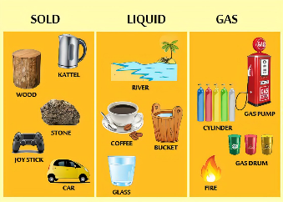 | In our Maths lessons, we will continue to consolidate our learning on place value, area, addition and subtraction. We will also explore the relationship between multiplication and division. In order to be successful in these lessons, it is essential that the children continue to work on their times tables and speed up their recall of times table and division facts.  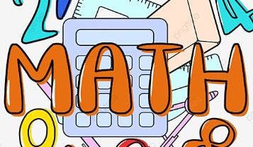 | In English, we will be reading, reciting and enjoying simple riddles before writing our own. We will then focus on the text ‘I was a Rat!’ to write a narrative, exploring the use of description and setting. To finish, we will write a non-chronological report about life in modern Greece showcasing our geography learning.  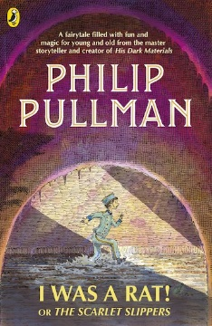

Diary Dates:  Our PE days are Tuesday and Thursday. As it will be getting cooler, tracksuits/ jogging suits or a warm jumper may be worn and appropriate training shoes. All jewellery must be removed during PE sessions.  Tuesday 26th – Wednesday 27th November – Parents Evening.  Friday 13th December – Open Doors Afternoon.  Wednesday 18th – Friday 20th December – Herd Farm residential. | Class routines:  - The children are expected to read at home every night. Reading records and books should be brought to school every day so that a member of staff can read with them in school. These reading books will be changed on a Friday if the reading record has been signed.  - Each Friday, the children will complete a spelling quiz. The spellings focus will be sent home on a Friday, ready to learn for the following Friday. The children will need to practise these at home (and at school) on a regular basis.  - Pupils should log onto TTRockstars to improve their times tables knowledge. This is constantly monitored as well as accessed in class to prepare the children for their Multiplication Times Table Check in June.
Finally, please remember to log onto the class page on the school website to keep up to date with our latest news: https://www.crossgatesprimary.co.uk/class-pages/ or by accessing the school twitter page.
Miss Beaumont & Miss Croft

