Year 4 Newsletter (Autumn 1)

Welcome to Year 4, Fine class! We hope you had a restful summer break and you are looking forward to the new school year.
Our learning journey
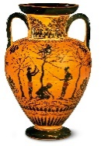  In history, we will be exploring the topic of Ancient Greece, studying the Greek life and their influence on the western world. We will discover how Ancient Greece was not a country; it was made up of city states. There were often battles between these city states but sometimes they would join together against a common enemy. The important city states of Ancient Greece include Athens, Corinth and Sparta. | Our focus this half term in Science is electricity. We will understand that a circuit has be complete to allow electricity to travel all the way around it. The children will build and explore a simple electrical circuit. They will discuss common appliances that run on electricity and investigate which materials are good conductors of electricity and which are not.   | In Maths, the focus is place value, where children will be recognising the value of each digit in a 4 digit number, ordering and comparing numbers beyond 1,000, counting backwards through 0 to include negative numbers and reading Roman numerals. We will then move onto addition and subtraction where children will add or subtract 4 digits numbers and learn how to exchange.  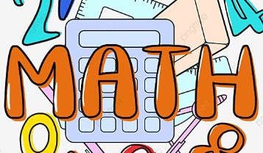 | In English, reading and writing will be based around our book: Greek Myths by Marcia Williams. The children will be writing their own myth inspired by those they read. They will learn how to write a set of detailed instruction and explore poetry inspired by Ancient Greece. They will be learning to include more description in their writing and improving spelling and handwriting is a key target this term.  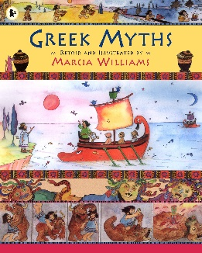

Diary Dates:  Your child now has swimming every Thursday, so your child will need their swimming costume and a towel in a bag.  Our PE is on a Tuesday. As it will be getting cooler, tracksuits/ jogging suits or a warm jumper may be worn and appropriate training shoes. All jewellery must be removed during swimming and PE sessions too.  Wednesday 16th October – Ancient Greece Day (more information to follow)  Wednesday 18th – Friday 20th December – Herd Farm (more information to follow) | Class routines:  - The children are expected to read at home every night. Reading records and books should be brought to school every day so that a member of staff can read with them in school. These reading books will be changed on a Friday if the reading record has been signed.  - Each Friday, the children will complete a spelling quiz. The spellings focus will be sent home on a Friday, ready to learn for the following Friday. The children will need to practise these at home (and at school) on a regular basis.  - Pupils should log onto TTRockstars to improve their times tables knowledge. This is constantly monitored as well as accessed in class to prepare the children for their Multiplication Times Table Check in June.

Finally, please remember to log onto the class page on the school website to keep up to date with our latest news: https://www.crossgatesprimary.co.uk/class-pages/ or by accessing the school twitter page.
Miss Beaumont & Miss Croft

