 | Animals including Humans.
 | Year Group: 4 | Subject Focus: Science | Term: Summer 2
Key facts  - You have two sets of teeth in your lifetime.  - Adults have 32 teeth whilst children only have 20.  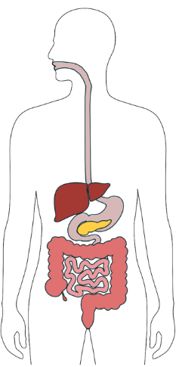  - Our stomach can stretch. An adult’s stomach can hold approximately 1.5 litres of food and drink.  - Our oesophagus is approximately 25cm long.  - It takes 7 seconds for food to travel to the stomach once you have swallowed it.  - Scientists believe we have wisdom teeth because our ancestors used to eat a lot of tougher foods, such as leaves and nuts, which needed grinding more. |  | Working Scientifically Skills  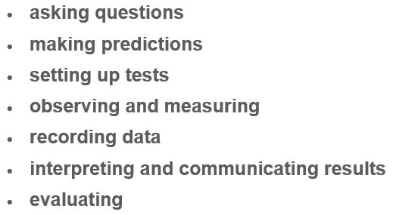    Children will persist in developing the above working scientifically skills throughout our sessions. In each lesson, a particular skill will be the focal point as they engage in their investigations. Our emphasis will be on demonstrating and modelling so that the children develop these skills further, for example interpret data and communicate results effectively. | Key words:  digestion the process of digesting food.  oesophagus a muscular tube which uses contractions to move the bolus from mouth to stomach.  stomach mix with acid and enzymes to turn food into paste.  incisor a narrow-edged tooth at the front of the mouth, adapted for cutting.  canine a pointed tooth between the incisors and premolars.  molar a grinding tooth at the back of the mouth.  premolar a tooth situated between the canine and the molar teeth.  producer an organism that makes its own food.  predator an animal that naturally preys on others.  prey an animal that is hunted and killed by another for food.
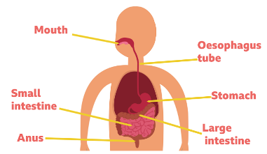
Did you know?
- The digestive system helps to break down the food for the body to process and use.
- Digestion happens in the digestive system. This is a series of organs that break down the food so it can be absorbed into our blood and travel around to where it is needed.
- Food enters the digestive system as soon as you put it in your mouth. This is where food is broken down by your teeth, mixed with saliva and swallowed.
- Once you have swallowed your food, it travels down your oesophagus into your stomach where the food is churned with stomach acid to kill any germs which may be on it.
 |  | Exciting books / web links:  What is the digestive system? - BBC Bitesize  Year 4: Animals, including humans | STEM  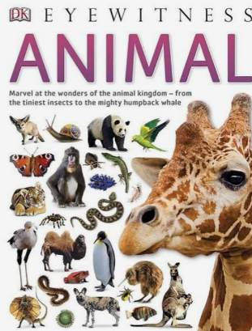  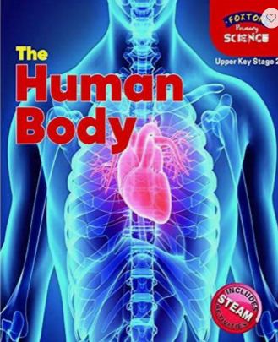 | Parents as partners:  - Discuss how to keep healthy.  - Look at a variety of common animals and sort them into groups using common characteristics.  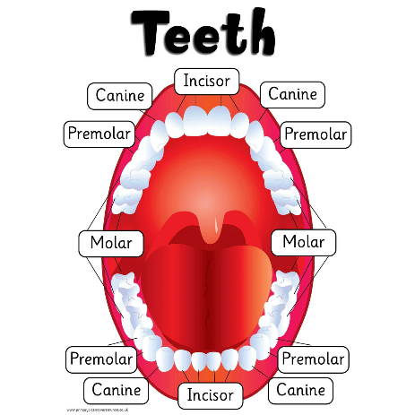  - Discuss the names of the main body parts.  - Use a mirror to identify and discuss the different types of teeth in humans their function.

