 | Living Things and their Habitats
 | Year Group: 4 | Subject Focus: Science | Term: Summer 2
Key facts  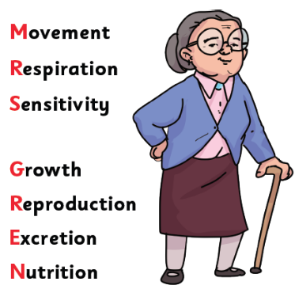  - There are seven things that all living things do, we call these life processes. All animals, including humans, do these and plants do too! We can remember them with the help of Mrs Gren!  - We can group animals into five different groups based on their characteristics.  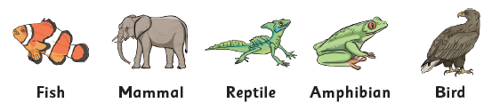 |  | Working Scientifically Skills  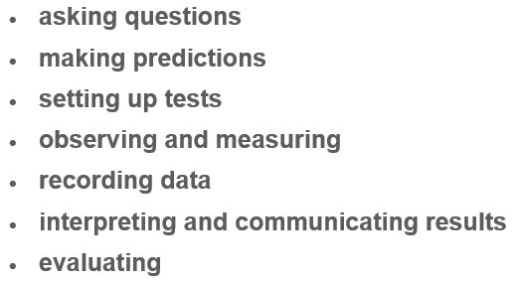    Children will persist in developing the above working scientifically skills throughout our sessions. In each lesson, a particular skill will be the focal point as they engage in their investigations. Our emphasis will be on demonstrating and modelling so that the children develop these skills further, for example interpret data and communicate results effectively. | Key words:  omnivore a living thing that eats both plants and meat  carnivore a living thing that just eats meat  herbivore a living thing that just eats plants  vertebrate animals with a backbone  invertebrate animals without a backbone  characteristics the distinguishing features or qualities that are specific to a species  habitat the natural environment where animals and plants live  classification key this is where plants or animals are placed into groups according to their similarities  human impact the impact humans have on the environment and habitats  specimen a particular plant or animal that a scientist studies to find out about the species
How else can we group animals?
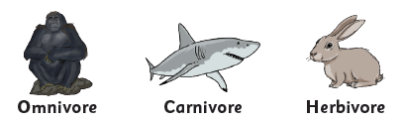
- We can also group animals based on the types of food they eat.

- We can also group animals based on whether they have a backbone (spine) or not.
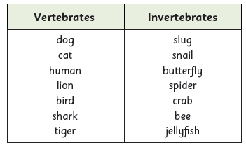

 |  | Exciting books / web links:  Habitats (nationalgeographic.com)  Living things and their habitats - Year 4 Science - BBC Bitesize  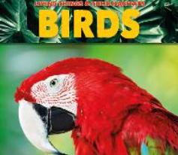  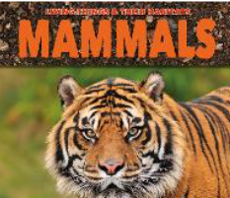  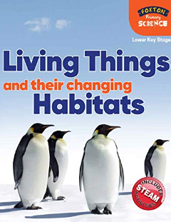  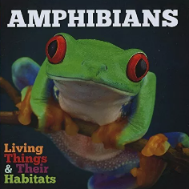 | Parents as partners:  - Discuss and describe some of the features or characteristics of the living things you see.  - Explore what living things you can find in your local environment.  - Discuss the effects that human activity has on the environment and some of the dangers this can have on living things.  