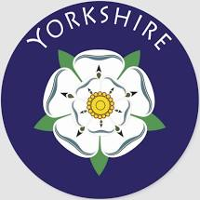 | Yorkshire |  |  | 
 | Year Group: 4 | Subject Focus: Geography | Term: Summer 2
Key facts  - England is a country in the United Kingdom, in the continent of Europe.  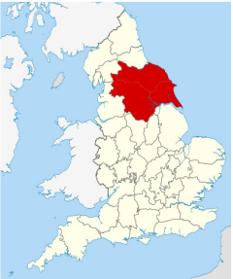  - Yorkshire is a county in North East England.  - The city of Leeds is Yorkshire’s largest city and is now the leading centre of trade and commerce in the region.  - Traditional industries included sheep, farming, textile manufacturing, coal mining and the steel industry.  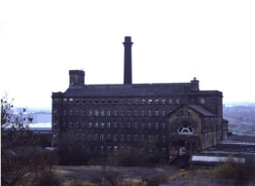  - There is much evidence of canals, mines, wool mills and heavy industry throughout Yorkshire. |  | - There are 109 counties of the UK.  - There are 48 counties in England.  - Yorkshire is made up of 4 counties: North Yorkshire, West Yorkshire, South Yorkshire and East Yorkshire.  - The main cities of Yorkshire are Leeds, York, Sheffield, Bradford, Middlesbrough and Hull.  - The main towns in Yorkshire are York, Ripon, Leeds, Bradford, Kingston upon Hull, Scarborough, Harrogate, Skipton, Whitby and Hebden Bridge.  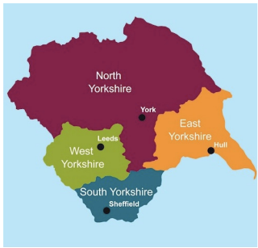  - The main rivers in Yorkshire are the River Swale, Ure and Nidd.  - The main mountains and hills in Yorkshire are Whernside, Ingleborough and Pen-y-ghent | Key words:  atlas a book of maps  capital city the city where the government sits. London is the capital city of England and the UK  cartography the making of maps  County A small area of the UK containing lots of towns and villages.  human geography the type of geography dealing with how human activity affects or is influenced by the earth's surface.  Great Britain England, Scotland and Wales  key gives you the information needed for the map to make sense.  landmark A feature of the landscape or area that is easily recognised  land use how humans have managed land for different activities  physical geography the type of geography dealing with natural features
Did you know?  - Tourism is significant in the region.  - North Yorkshire has an establish tourist industry.  - Previous industrial use of land has changed over time to nature reserves, shopping centres, bio mass and solar and wind power. |  | 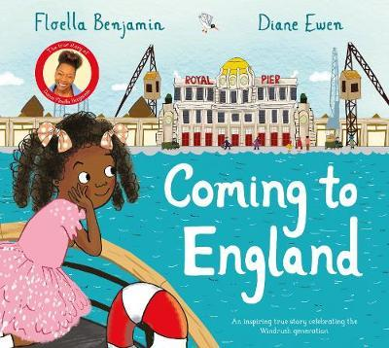  Exciting books/ web links:  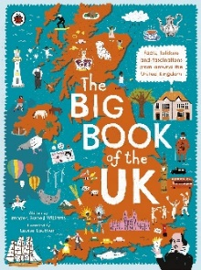  Sites to Visit in Yorkshire | English Heritage (english-heritage.org.uk) | Parents as partners:  - Encourage your child to create some amazing fact cards about Yorkshire.  - Use Google Earth and locate where you are on the map.  - Together, make a poster comparing Leeds and London.  - Create a word search or crossword about Yorkshire landmarks  - If you could visit somewhere in Yorkshire, where would it be? Look online and create an itinerary for a weekend visit. How many different activities could you include?

