 | Art: Painting and Mixed Media
 | Year Group: 4 | Subject Focus: Art | Term: Summer 2
Key facts:  - Mixed media art uses a combination of different materials.  - The materials used can be anything: paint, paper, cardboard, photographs, found objects, things from nature – anything!  - It encourages creativity and experimentation by combining materials and techniques into one piece of art.  - The roots of mixed media can be traced back to the ‘Cubist movement’, where artists like Picasso began incorporating collage and other mixed media techniques into their work.  Popular techniques include:  - Collage  - Assemblage  - Painting  - Digital mixed media  Take a look at BBC Bitesize for more information!  https://www.bbc.co.uk/bitesize/articles/z8sg8p3#zb6frmn |  | Famous Artwork:  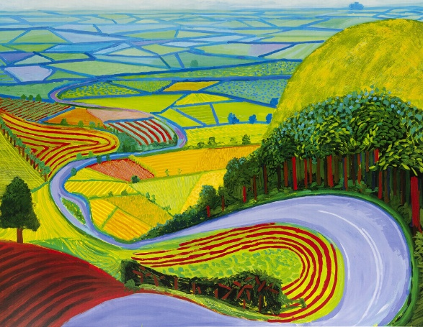  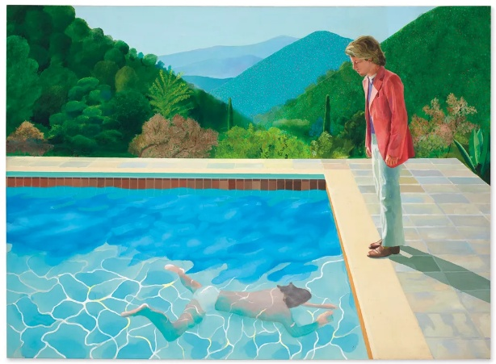  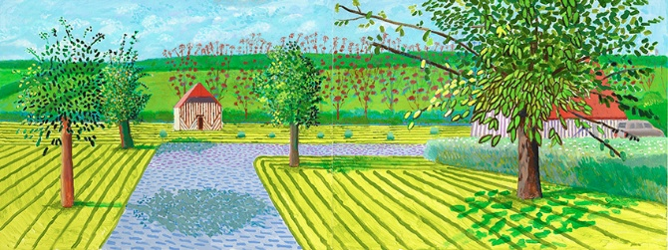 | Key words:  Art the expression of creative skill, which can be expressed in many ways  artist a person who creates art  mixed media artwork that uses two or more materials or techniques to create it  concept an idea behind a piece of art  background the part of the artwork that is behind the main subjects  technique the methods, skills and procedures an artist uses  collage a technique where various materials are assembled  evaluate to make a judgement about a piece of art  medium the material or substance used to create a piece of art  composition the way in which different elements of an artwork are combined or arranged  About the artists: David Hockney  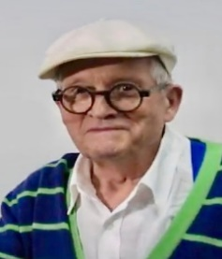  David Hockney is an English painter who has experimented with painting, drawing, printmaking, watercolours, photography and many other media.

