 | The Maya |  |  | 
 | Year Group: 4 | Subject Focus: History | Term: Summer 1
Key facts  - Maya cities had similar layouts to each other. They would have a palace for the ruler, a plaza for the market places and temples in the form of pyramids.  - Maya cities were often found near trade routes and good farmland.  - Mayas were polytheists – believing in many nature Gods or deities.  - Priests were considered the most important people in the Maya culture: warriors, craftsmen and traders were next in the hierarchy. Farmers, workers and slaves were at the bottom of the hierarchy.  - Maya merchants traded many goods: salt, cotton, honey and jade.  - The Maya calendar (Tzolkin) consisted of 260 days and 13 months.  - The demise of the Mayan civilisation came about because of a mixture of deforestation, land erosion and drought. |  | 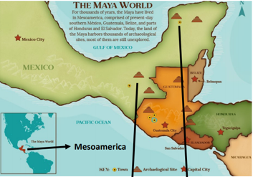  We will look at:  - how the Maya civilisation has had an impact on modern society.  - times of little change and times of great change.  - the ideas, beliefs and attitudes of all groups of people in Maya civilisation.  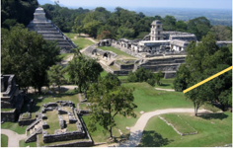 | Key words:  architecture The art of planning, designing and constructing buildings.  chronology The order of events in time.  civilisation A human society with its own organisation and culture.  continent A large area of land that covers many countries.  culture Activities such as arts and philosophy – important for the development of civilisation.  demise Something or someone who is at their end or death.  drought A long period with no rain.  economy The wealth that a society or country gets from business or industry.  Mayan Relating to the characteristics of the Maya people and their language.  Mesoamerica Central America – Mexico, Guatemala, El Salvador, Belize.
Did you know?
- South America is a continent.
- The climate in South America is different to the UK.
- Other civilisations include the Egyptians and the Greeks.
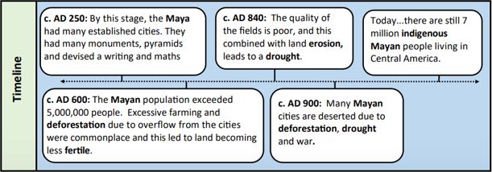
 |  | Exciting books/ web links:  https://www.dkfindout.com/uk/history/mayans/  https://www.ducksters.com/history/maya/daily_life.php  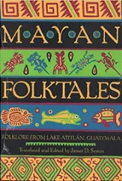  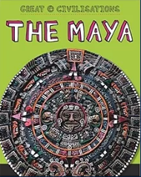  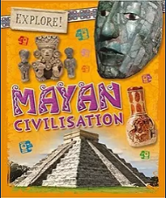 | Parents as partners:  You could do some research online with your child.  Find some interesting facts about the Maya.  Read a story that is connected to the Maya civilisation.  