 | DT: Torches
 | Year Group: 4 | Subject Focus: DT | Term: Summer 1
Key Knowledge:  - Identify electrical products and explain why they are useful.  - Help to make a working switch.  - Identify the features of a torch and how it works.  - Describe what makes a torch successful.  - Create suitable designs that fit the success criteria and their own design criteria.  - Create a functioning torch with a switch according to their design criteria.  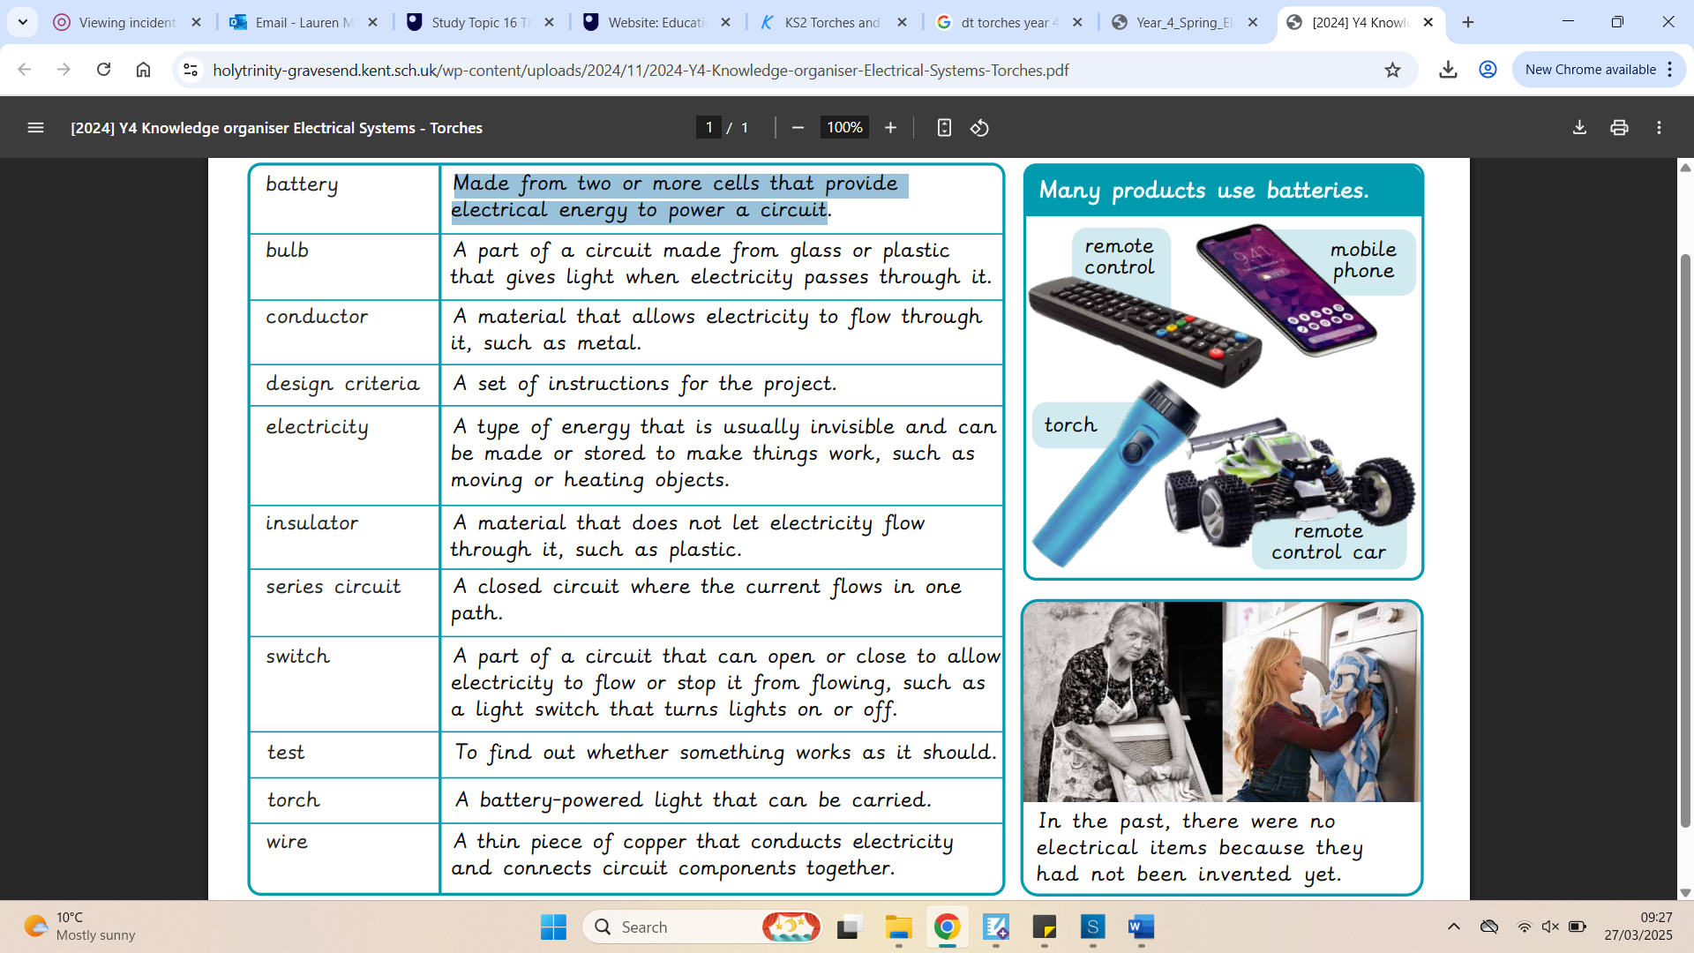  Useful and Reliable Websites  - BBC Bitesize - Design and Technology  - Primary Homework Help  - Tech Club - Making a Torch |  | 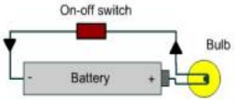  Technical Knowledge:  This is a series circuit: the battery contains stored electricity and this is used to power the bulb. When the switch is turned on, the electrical current flows through the conducting material.  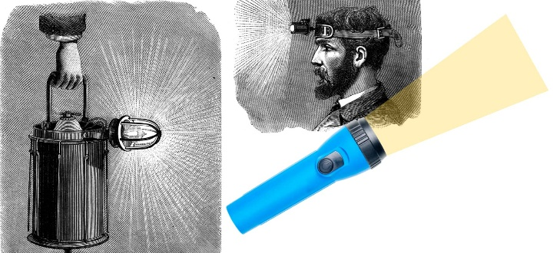  Facts:  - The word "torch" is commonly used in British English for what is referred to as a "flashlight" in American English.  - LED (Light Emitting Diode) torches consume less power and last much longer than traditional light bulbs.  - The first torches were made using gas or oil, which were bulky and not very safe compared to modern designs.  - The UK is home to one of the largest manufacturers of torches and lighting products in the world! | Key words:  Battery: Made from two or more cells that provide electrical energy to power a circuit.  Conductor: A material that allows electricity to flow through it, such as a metal.  Design Criteria: A set of instructions for the project.  Electricity: A type of energy that is usually invisible and can be made or stored to make things work, such as moving or heating objects.  Insulator: A material that does not let electricity flow through it, such as plastic.  Series Circuit: A closed circuit where the current flows in one path.  Switch: A part of a circuit that can open or close to allow electricity to flow or stop it from flowing, such as a light switch that turns on or off.  Test: To find out whether something works as it should.  Torch: A battery-powered light that can be carried.  Wire: A thin piece of copper that conducts electricity and connects circuit components together.
?

