 | Sound
 | Year Group: 4 | Subject Focus: Science | Term: Spring 2
Key facts  - A sound produces vibrations which travel through a medium from the source to our ears.  - Different mediums such as solids, liquids and gases can carry sound.  - The vibrations cause parts of our body inside our ears to vibrate, allowing us to hear (sense) the sound.  - The loudness (volume) of the sound depends on the strength (size) of vibrations which decreases as they travel through the medium. Therefore, sounds decrease in volume as you move away from the source.  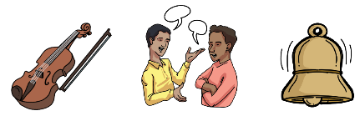  - A sound insulator is a material which blocks sound effectively. |  | Working Scientifically Skills  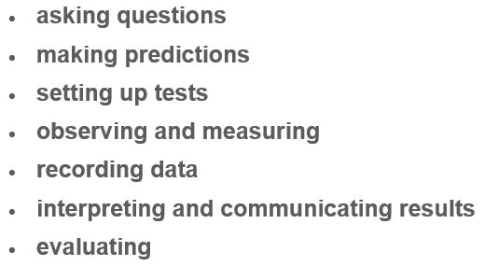    Children will persist in developing the above working scientifically skills throughout our sessions. In each lesson, a particular skill will be the focal point as they engage in their investigations. Our emphasis will be on demonstrating and modelling so that the children develop these skills further, for example interpret data and communicate results effectively. | Key words:  vibrate forward and backward movement of an object (usually rapidly).  volume how loud or quiet a sound is.  pitch how high or low a sound is.  sound vibrations that travel through the air or another medium that can be heard.  source a vibrating object that generates sound waves.  travel when an object vibrates it produces a longitudinal wave which travels through the air to your ear.  faint a sound that is not strong or clear.  loud a sound that is really strong or clear.  insulation absorbing or reflecting sound waves in order to reduce the amount of noise.  ear drum the membrane which collects sound.
Did you know?
- Sound cannot travel through a vacuum (an area empty of matter).
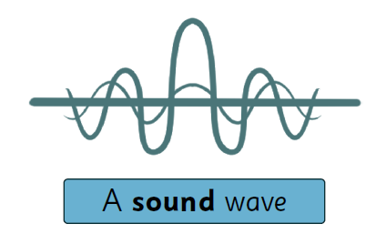
- Sound travels much slow than light. Light travels at 186,000 miles per second, whilst sound travels at 770 miles per second.
- You measure sounds that humans can hear in decibels (dB)
- Sound waves need particles in the air to travel therefore there is no sound in space because there are no particles for the sound to bound off from.
- Vibrations can not travel in straight lines, they travel in waves.
 |  | Exciting books / web links:  Fun Sound Science Experiments (science-sparks.com)  Sound - KS2 Science - BBC Bitesize  7 Cool Sound Science Experiments for Kids | Article (kidsacademy.mobi)  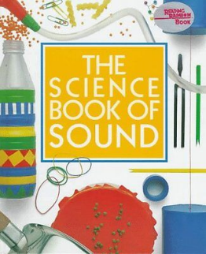  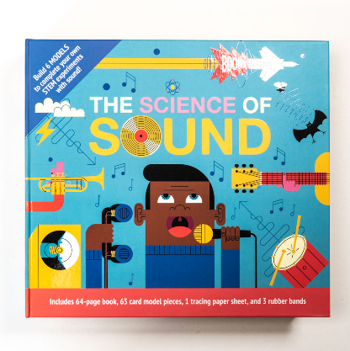 | Parents as partners:  - Explore making sound with a range of objects, such as musical instruments and other household objects.  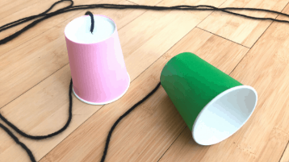  - Explore how string telephones work.    - Explore altering the pitch or volume of objects, such as the length of a guitar string, amount of water in bottles or size of tuning forks.  - Measure sounds over different distances.  - Measure sounds through different insulation materials.

