 | States of Matter
 | Year Group: 4 | Subject Focus: Science | Term: Spring 1
Key facts  - Materials can either be a solid, liquid or gas.  - Solids retain their shape and can be held. Sometimes solids can behave like liquids if they are made up of lots of small parts, for example sand or sugar. However, these are still solids as the individual grains of each retain their shapes.  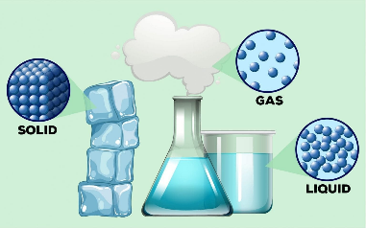  - Liquids take on the shape of the container they are in and can be poured.  - Gases are often invisible. They spread out to fill the space or container they are in. |  | Working Scientifically Skills  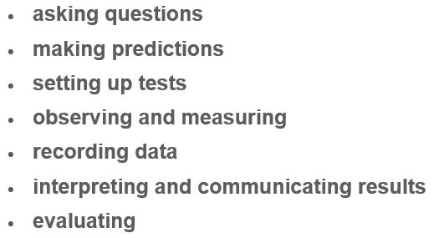    Children will persist in developing the above working scientifically skills throughout our sessions. In each lesson, a particular skill will be the focal point as they engage in their investigations. Our emphasis will be on demonstrating and modelling so that the children develop these skills further, for example interpret data and communicate results effectively. | Key words:  heating transferring thermal energy from something of a higher temperature to a lower temperature object.  cooling causing an object to decrease in temperature.  melting this is when a solid changes to a liquid.  melting point the point a solid changes to a liquid.  boiling the action of bringing a liquid to the temperature at which it bubbles.  boiling point the point where the liquid turns to vapour.  condensation when a gas turns into a liquid.  freezing liquid turns to a solid during the freezing process.  evaporation when a liquid turns into a gas.  temperature the degree of heat present in a substance or object.
Did you know?
- Solids can become liquids through heating; this process is called melting.
- Liquids can become gases through heating; this process is called evaporation.
- Gases can become liquids through cooling; this process is called condensation.
- Liquids can become solids through cooling; this process is called solidification or freezing.
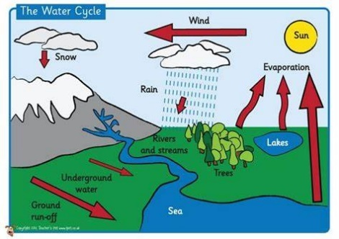
- Water freezes at 0 degrees and boils at 100 degrees.
 |  | Exciting books / web links:  States of matter - KS2 Science - BBC Bitesize  https://youtu.be/02qBuiqe7qI  States of Matter • ABCya!  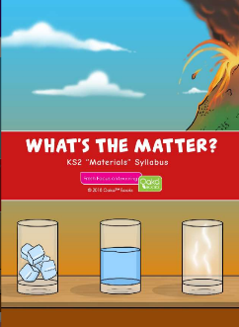  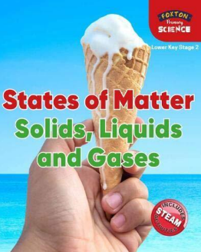 | Parents as partners:  - Test different materials to see which would make the best insulator to slow down the melting of an ice cube.  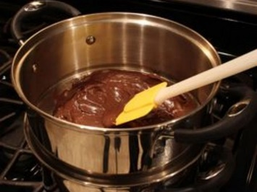  - Melt some chocolate and watch it change from a solid to a liquid when heated and back to a solid when cooled.  - Investigate which type of chocolate melts fastest, or look at the speed at which other solids melt.  - Observe a puddle over time, explain why the puddle disappears.

