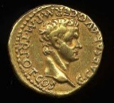 | The Romans |  |  | 
 | Year Group: 4 | Subject Focus: History | Term: Spring 1
Key facts:  - There were around five thousand soldiers in a Roman Army legion.  - Before the Romans arrived, Britain had no real roads.  - The Romans invaded and conquered many countries in Europe before heading to Britain.  - Boudicca was a Celtic Queen.  - Scotland was known as Caledonia.  - The Romans left their mark on Britain leaving us with new towns, plants and ways reading and counting.  Timeline:  55 BC – The first raid  The Roman General Julius Caesar came across the sea to Britain. He brought with him two Roman legions as he wanted to make Britain a part of the Roman Empire.  54 BC – The second raid  A year later, Julius Caesar came back across the sea. This time he brought with him five legions and two thousand cavalrymen (soldiers who fight on horses).  AD 43 –  About one hundred years later, the Romans returned. Emperor Claudius was now in charge and he was determined to make Britain part of the Roman Empire.  AD 60 – Rebellion against Romans  Tribes, which were led by Boudicca, attacked the Roman forces.  AD 410 –  Romans left Britain and returned to Italy. |  | 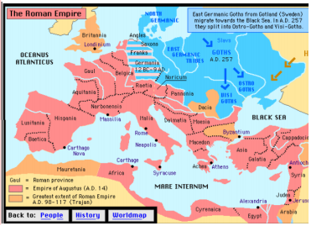  Map of the Roman Empire | Key words:  archaeologist someone who studies the past by exploring old remains  artefact an object from the past that shows evidence of what life was like  emperor somebody who rules an empire or is the head of state in an empire  empire a number of individual nations that are all controlled by the government or ruler of one particular country  infrastructure the basic facilities such as transport, communications, power supplies and buildings which enable it to work  invasion to try and take over a place by force  raid a sudden armed attack against a place  rebellion fighting back and opposing the people who have attacked you  Roman related to or connected with ancient Rome and its empire  settler/ settlement people who migrate to a new place and when people start a community it is called settlement
Important people:
Emporer Claudius – the first Roman emperor to successfully invade Britain
Julius Caesar – a famous Roman leader who attempted to invade Britain
Boudicca – a Saxon queen who fought back against the Romans
Paulinus – a Roman governor (ruler) of Britain in AD 60
Romulus and Remus –mythical twin brothers and founders of Rome

Exciting books/ weblinks:
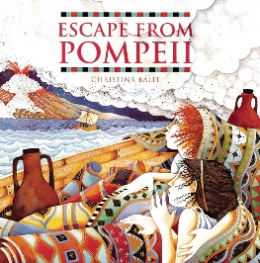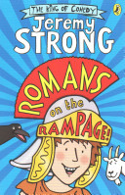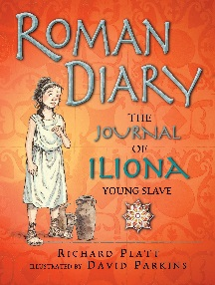

Parents as partners:
- Research life as a Roman (what did they wear, what did they eat?).
- Help your child make a model Roman villa.
- Together, use squared paper to design a Roman inspired mosaic.
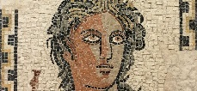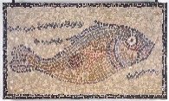

Did you know?
- The Romans are famous for their long, straight roads.
- Latin was the language spoken and written by the Romans.
- The Roman system for counting was based on seven different symbols: I, V, X, L, C, D, M.

