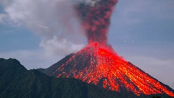 | Volcanoes |  |  | 
 | Year Group: 4 | Subject Focus: Geography | Term: Spring 2
Key facts  Volcanoes are made when pressure builds up inside the earth. This affects the earth’s crust causing magma to sometimes erupt through it.  There are three types of volcanoes: active (have erupted in the last 10,000 years), dormant (haven’t erupted in the last 10,000 years but may erupt again) and extinct volcanoes (aren’t expected to erupt again).  The different parts of a volcano include the main vent, ash cloud, lava flow, layers of ash and solidified lava, crater, conduit and the magma reservoir.  Earthquakes are caused when the earth’s tectonic plates suddenly move. Most earthquakes occur near the tectonic plate boundaries.  Earthquakes can cause lots of damage to roads, buildings and property. |  | A natural disaster is an event caused by nature such as volcanic eruptions, tornadoes, earthquakes and many more. These events cause great financial hardship for the people and communities in locations where they occur and they can sometimes even result in loss of life.  The earth is made up of many layers. This includes the crust, mantle, outer core and inner core.  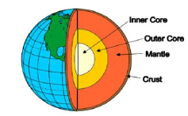  The crust is the thin outer layer made from hard rock; the mantle is extremely hot rock that flows; the outer core is made from iron and nickel and is mostly liquid with some rocky parts and the inner core is made from iron and nickel and is the hottest layer. | Key words:  active has erupted in the last 10,000 years  dormant hasn’t erupted in the last 10,00 years but may erupt again  eruption to suddenly burst out causing lava to explode out of the earth’s surface  extinct a volcano that has shown no activity for over 10,000 years and is not expected to erupt again  lava molten rock thrown out of volcanoes, which hardens as it cools  magma extremely, hot liquid rock inside the earth’s crust  ‘Ring of fire’ a circle of active volcanoes found around the edge of the Pacific Ocean  crater the big, hollow areas inside a volcano  volcano mountain with a vent through which lava is ejected  crust the thin outer layer of the Earth made from hard rock.
Exciting books/ web links:

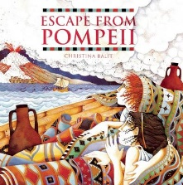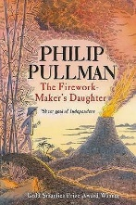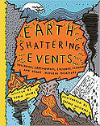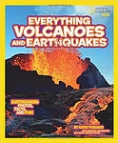
Did you know?  - In ancient Greece, people believed that the god of the sea, Poseidon, caused earthquakes. When he was angry, Poseidon would strike the ground with his trident and set off an earthquake. His unpredictable, violent behaviour earned him the nickname “Earth-Shaker”.  - The word volcano comes from the name Vulcan, the Roman god of fire.  - A tsunami can travel at up to 600 miles an hour – faster than a jet plane! |  | Parents as partners:  - Use this great interactive resource to explore where volcanoes are in the world and find out more about them: search Google Earth Volatile Volcanoes.  - Follow this tutorial to complete a science experiment with volcanoes (https://www.youtube.com/watch?v=8AqoOOJ3H_I)  - What information can you found out about the most active volcano and dangerous earthquake?

