Year 4 Newsletter (Spring 1)

Welcome back to Year 4 - Fine class! I hope you had a lovely Christmas. As we embark on the second term, get ready for a wealth of learning experiences and engaging projects.
Our learning journey
Our History unit for this half term will be the Roman Empire and its impact on Britain.  We will develop our understanding of why the Romans invaded Britain 2000 years ago. We will also explore how the Roman Empire achieved its invasion of Britain, looking at their powerful army and weapons.  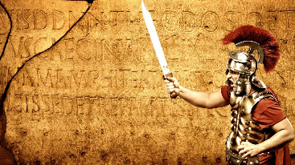 | In Science, we will continue our learning on states of matters. Then move onto Sound.    We will finish our learning by looking at the processes of condensation and evaporation. We will learn how vibrations cause sounds and how sounds travel through different mediums at different speeds. The children will discover how sounds can change in pitch and loudness. | In our Maths lessons, we will focus on using formal methods for multiplication and division. In order to be successful in these lessons, it is essential that the children continue to work on their times tables and speed up their recall of times table and division facts. We will then finish the half term exploring length and perimeter.  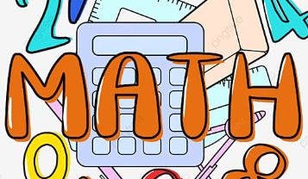 | In English, we will begin by researching a famous poet: Allan Ahlberg. We will recite and perform his poem ‘Please, Mrs Butler’ by heart. We will then focus on writing a playscript based on a section of Julius Caesar – Tales from Shakespeare. Finally, we will compose a letter home from a Roman soldier, showcasing our History learning.  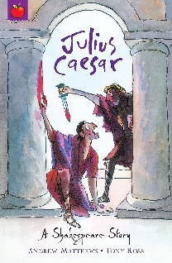

Diary Dates:  PE will take place on a Wednesday and Thursday. The children need to come to school in their uniform on these days and bring the full PE kit. They will also need a water bottle.  On Monday 3rd – Tuesday 4th February, we will be taking part in bikeability.  On Friday 7th February, we will be celebrating NSPCC Number Day by dressing up as a digit as well as welcoming a science specialist to teach us all about the Science of Sound. | Class routines:  - The children are expected to read at home every night. Reading records and books should be brought to school every day so that a member of staff can read with them in school. These reading books will be changed on a Friday if the reading record has been signed.  - Each Friday, the children will complete a spelling quiz. The spellings focus will be sent home on a Friday, ready to learn for the following Friday. The children will need to practise these at home (and at school) on a regular basis.  - Pupils should continue to log onto TTRockstars to improve their times tables knowledge. This is constantly monitored as well as accessed in class to prepare the children for their Multiplication Times Table Check in June.
Finally, please remember to log onto the class page on the school website to keep up to date with our latest news: https://www.crossgatesprimary.co.uk/class-pages/ or by accessing the school twitter page.
Miss Beaumont & Miss Croft.

