 | The Maya |  |  | 
 | Year Group: 4 | Subject Focus: History | Term: Summer 1
Key facts  - Mayan cities had similar layouts to each other. They would have a palace for the ruler, a plaza for the market places and temples in the form of pyramids.  - Mayan cities were often found near trade routes and good farmland.  - Mayans were polytheists – believing in many nature Gods or deities.  - Priests were considered the most important people in the Mayan culture, warriors, craftsmen and traders were next in the hierarchy. Farmers, workers and slaves were at the bottom of the hierarchy.  - Mayan merchants traded many goods including; salt, cotton, honey and jade.  - The Mayan calendar (Tzolkin) consisted of 260 days and 13 months.  - The demise of the Mayan civilisation came about because of a mixture of deforestation, land erosion and drought. |  | 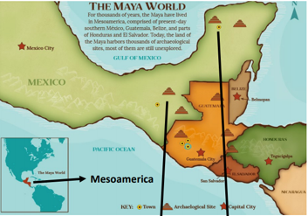  We will look at:  - how the Mayan civilisation has had an impact on modern society.  - times of little change and times of great change.  - the ideas, beliefs and attitudes of all groups of people in Mayan civilisation.  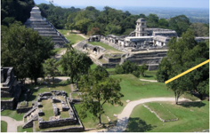 | Key words:  architecture The art of planning, designing and constructing buildings  chronology The order of events in time  civilisation A human society with its own organisation and culture  continent A large area of land that covers many countries  culture Activities such as arts and philosophy – important for the development of civilisation  demise Something or someone who is at their end or death  drought A long period with no rain  economy The wealth that a society or country gets from business or industry  Mayan Relating to the characteristics of the Maya people and their language  Mesoamerica Central America – Mexico, Guatemala, El Salvador, Belize
Did you know?
- South America is a continent.
- The climate in South America is different to the UK.
- Other civilisations include the Egyptians and the Greeks.
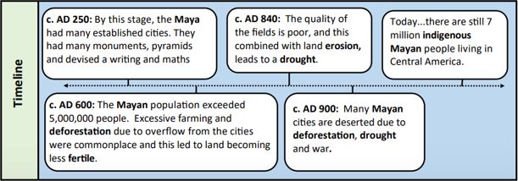
 |  | Exciting books/ web links:  https://www.dkfindout.com/uk/history/mayans/  https://www.ducksters.com/history/maya/daily_life.php  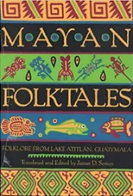  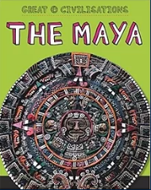  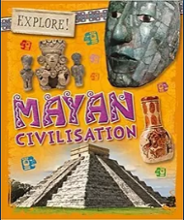 | Parents as partners:  You could do some research online with your child.  Find some interesting facts about the Maya.  Read a story that is connected to the Mayan civilisation.  