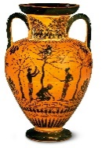 | Ancient Greece |  |  | 
 | Year Group: 4 | Subject Focus: History | Term: Autumn 1
Key facts  Ancient Greece was not a country. It was made up of city states. There were often battles between these city states but sometimes they would join together against a common enemy. The important city states of ancient Greece included Athens, Corinth and Sparta.  Around 508 BC, democracy was introduced to ancient Athens. Listening to the opinions of other people and debating issues was an important part of this system.  The first recorded Games was in 776 BC, in Olympia. The event was part of a festival to honour the Greek god, Zeus.  Women were not allowed to compete in the Olympics. This was because ancient Greek women were not treated as equals to men and had fewer freedoms.  There were many events: boxing, wrestling, running and chariot racing. |  | Ancient Greece is important historically because many things in culture today, especially in modern Europe, have been influenced by the ideas of the ancient Greek civilisation.  Timeline  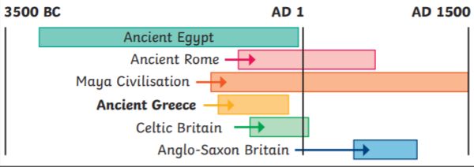 | Key words:  ancient Something from a very long time ago.  assembly A group of citizens who turned up to vote  citizens An inhabitant of a town or city.  city states Small areas that ancient Greece was divided into, each with their own governments, laws and army.  civilisation In this context, the word ‘civilisation’ is used to describe a human society with well-developed rules and government, often where technology and the arts are considered important.  democracy Democracy is a system where the citizens of a country or state are involved in the way it is run.  dictatorship Ruled by one person (a dictator) who has total power over a country.  empire A group of countries or states that is ruled by one ruler or country.  myth A traditional story explaining the history of people or a natural phenomenon.  Olympics An athletic event held every 4 years.
Exciting books/ web links:

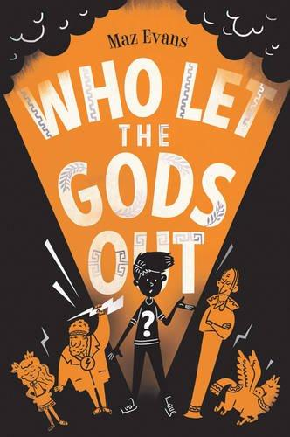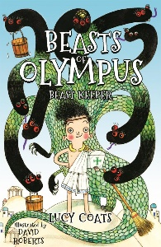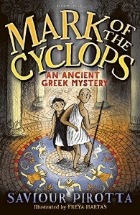
Did you know?  - Over 3000 years later, we are still using ancient Greek ideas in maths, science and art. Our alphabet is based off the Greek one and in the dictionary, there are hundreds of words that come from the Greek language.  - The Greeks development of democracy is still our main form of government today.  - They invented the theatre and the Olympic Games which we still currently enjoy. |  | Parents as partners:  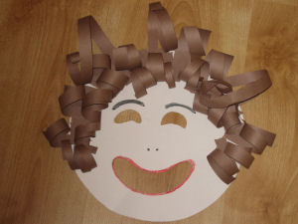  - Actors in Greek theatre wore masks to depict different characters and emotions, design and make a Greek mask.  - Winners were usually awarded with a crown made of olive leaves at the ancient Olympic Games; make your own olive leaf crown.  - What information can you find about ancient Greek inventions that are still used today? | Greek Gods and Goddesses  The ancient Greeks believed in many different gods and goddesses. Each god/goddess represented a certain aspect of humanity and each was responsible for certain parts of life too. It is believed that the 12 most powerful gods lived on Mount Olympus.  The ancient Greek gods and goddesses were included in many of the myths that the ancient Greeks told one another. Zeus was the most powerful of all gods: he was the god of the sky and the king of Mount Olympus.

