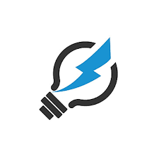 | Electricity |  |  | 
 | Year Group: 4 | Subject Focus: Science | Term: Autumn 1
Key facts  Some common appliances that run on electricity are TV’s, washing machines, Switch and hair dryers.  The main components of a circuit are: cells, wires, bulbs, switches and buzzers.  A lamp will light if a circuit has a source of electricity, a bulb and is a complete circuit.  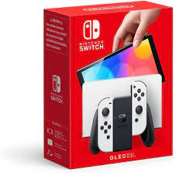  A switch is used to open and close a circuit. This can be used to light a lamp in a simple series circuit or turn it off. Switches are used to break circuits so that bulbs, buzzers and motors are off or complete a circuit  so that they are on. |  | 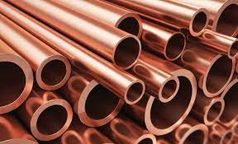  Conductors are substances that electricity can pass through easily. Copper, iron and steel are good conductors.  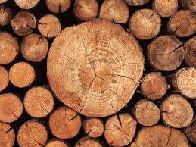  Insulators are materials that do not allow electricity to pass through. Plastic, wood, glass and rubber are good insulators and this is why they are used to cover materials that carry  electricity. | Key words:  electricity form of energy resulting from the existence of charged particles  Complete circuit complete circular path that electricity flows through  component part or element of a larger whole  cell Devise that can generate electrical energy  bulb A light bulb  switch device for making and breaking the connection in an electric circuit  buzzer electrical device that makes a buzzing sound  conductor material that allows electricity to pass through it  insulator material that does not allow electricity to pass through it  Crocodile clip Spring loaded clip that creates a temporary electrical connection
Exciting books/ web links:
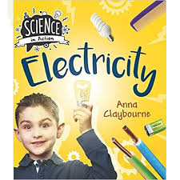
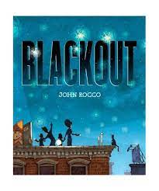
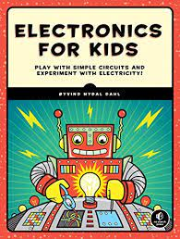

If you enjoy making circuits and learning about electricity you might like a career (job) working as:  - Electrical Engineer (works with equipment that uses electricity)  - Electrician (installs and maintains electrical equipment)  - Renewable Energy Engineer (works on environmentally conscious energy production) |  | Parents as partners:  Use the questions below to start a conversation about electricity.  - Where do we use electricity in our everyday lives?  - What if there was no electricity?  - Where can we find switches in our school/home?  - Why are insulators just as important as conductors?
Did you know?
Thomas Edison was an American scientist who is credited with inventing the light bulb
