 | Art: Clay Pots
 | Year Group: 4 | Subject Focus: Art | Term: Spring 1
Key Knowledge:  - Clay is a natural material made up of tiny particles of rock. When mixed with water, it feels like soft, gluey mud and can be pinched, rolled, cut, or built up in layers to form many different shapes.  - Clay holds its shape and hardens as it dries.  - Pottery is the art of making containers, sculptures and other objects of clay.  - Clay is shaped and then fired, or baked at a high temperature, to harden it. The items created in this way are also called ceramics  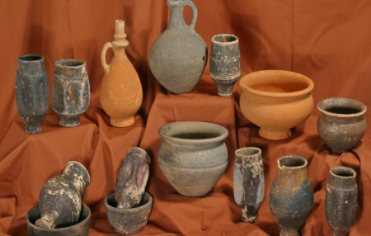  Romans used pottery for many of their everyday items. Roman pottery was influenced by ancient Greek pottery; however, Roman pottery often had decorations cut into it. By contrast, the ancient Greeks painted images on their pottery |  | Technical Knowledge:  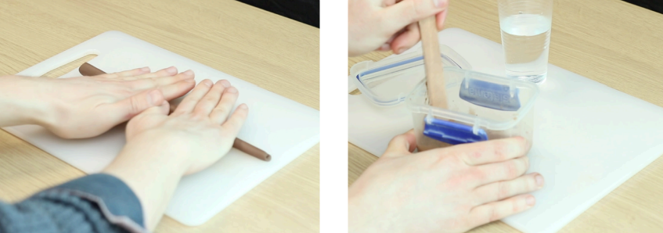  Making slip  Slip is a runny mixture of clay and water. Potters use slip to join two pieces of clay together.  Rolling coils  Coils are long, round rolls of clay. Coils can be used one on top of another to make a clay pot.  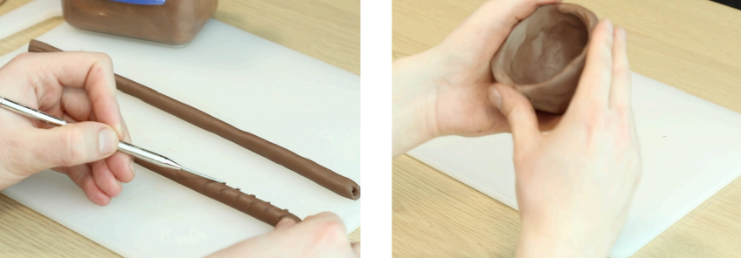  .  Making a pinch pot  A pinch pot is a simple clay pot made by sticking a thumb into a ball of clay and then pinching the clay between the thumb and the fingers.  Joining clay  Potters score clay and apply slip to join two pieces of clay together. This method of joining is called the score and slip technique. | Key words:  Clay A stiff, sticky fine-grained earth that can be moulded when wet  Score To make a mark or cut on the surface of something with a pointed tool.  Pinching Squeezing between thumb and finger  Sculpt To make a form by carving, chiselling, modelling or casting  Joining To attach parts together  Texture How something feels when touched  Malleable Can be easily transformed with hands or tools  Carve Cutting to produce a design  Sketching A rough drawing to prepare  Slip A clay slurry used to produce pottery and other ceramic items.  Quick Quiz  Can you name 3 different objects that are made out of clay?  Can you name an artist that uses clay and describe his or her work?  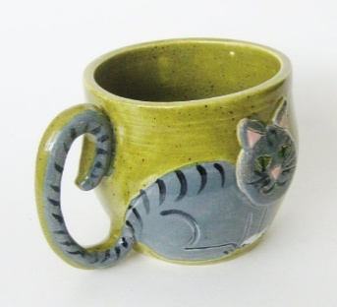  Can you explain 3 techniques that are used to mould clay into different shapes?
?

