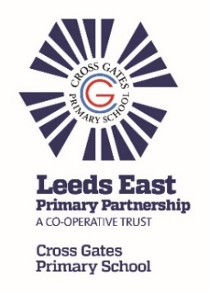

**HOMEWORK-** Pleaseensure that your child practises words from their spelling lists, reads daily for 10 to 20 minutes and completes online learning tasks such as TTRock Stars and Numbot programmes to support their learning. Please see the front page of the Reading Record for TTRS log in.

Please can I remind you that we have **swimming** every Thursday, so your child will need their swimming costume and a towel. Our **PE** is on a Tuesday. As it will be getting cooler, tracksuits/ jogging suits or a warm jumper may be worn and appropriate training shoes. All jewellery must be removed during swimming and PE sessions too.

If your child is unable to join in during these lesson you will need to provide school with a written note on a weekly basis, otherwise they will be required to join in the lessons.

Dear Parents and Carers,

We hope that you have had a restful summer break and that your child is looking forward to the new school year.

In **English**, reading and writing will be based around our book: Greek Myths by Marcia Williams. The children will be writing their own myth inspired by those they read. They will learn how to write a set of detailed instruction and explore poetry inspired by Ancient Greece. They will be learning to include more description in their writing and improving spelling and handwriting is a key target this term.

In **Maths**, the focus is place value, where children will be recognising the value of each digit in a 4 digit number, ordering and comparing numbers beyond 1,000, counting backwards through 0 to include negative numbers and reading Roman numerals. Following on from Year 3, everyone will be practising their key number facts and times tables using Numbots and Times Tables Rock Stars. They will be expected to practise these at home too so please speak to us if you have any problems logging into the website.

Our focus this half term in **Science** is electricity*.* The children will build and explore a simple electrical circuit. They will discuss common appliances that run on electricity and investigate which materials are good conductors of electricity and which are not.

We will be recapping greetings and our numbers to ten in **French** and then learning our body parts. In **Art/DT**, we will be drawing a Grecian urn with a modern twist.

**Don’t forget to look on twitter and the Class webpage for updates, photos and information.**

[**www.crossgatesprimary.co.uk**](http://www.crossgatesprimary.co.uk)

**@CGPrimarySchool**

|  |  |
| --- | --- |
|  | Year Four NEWSLETTER  September 2023 |

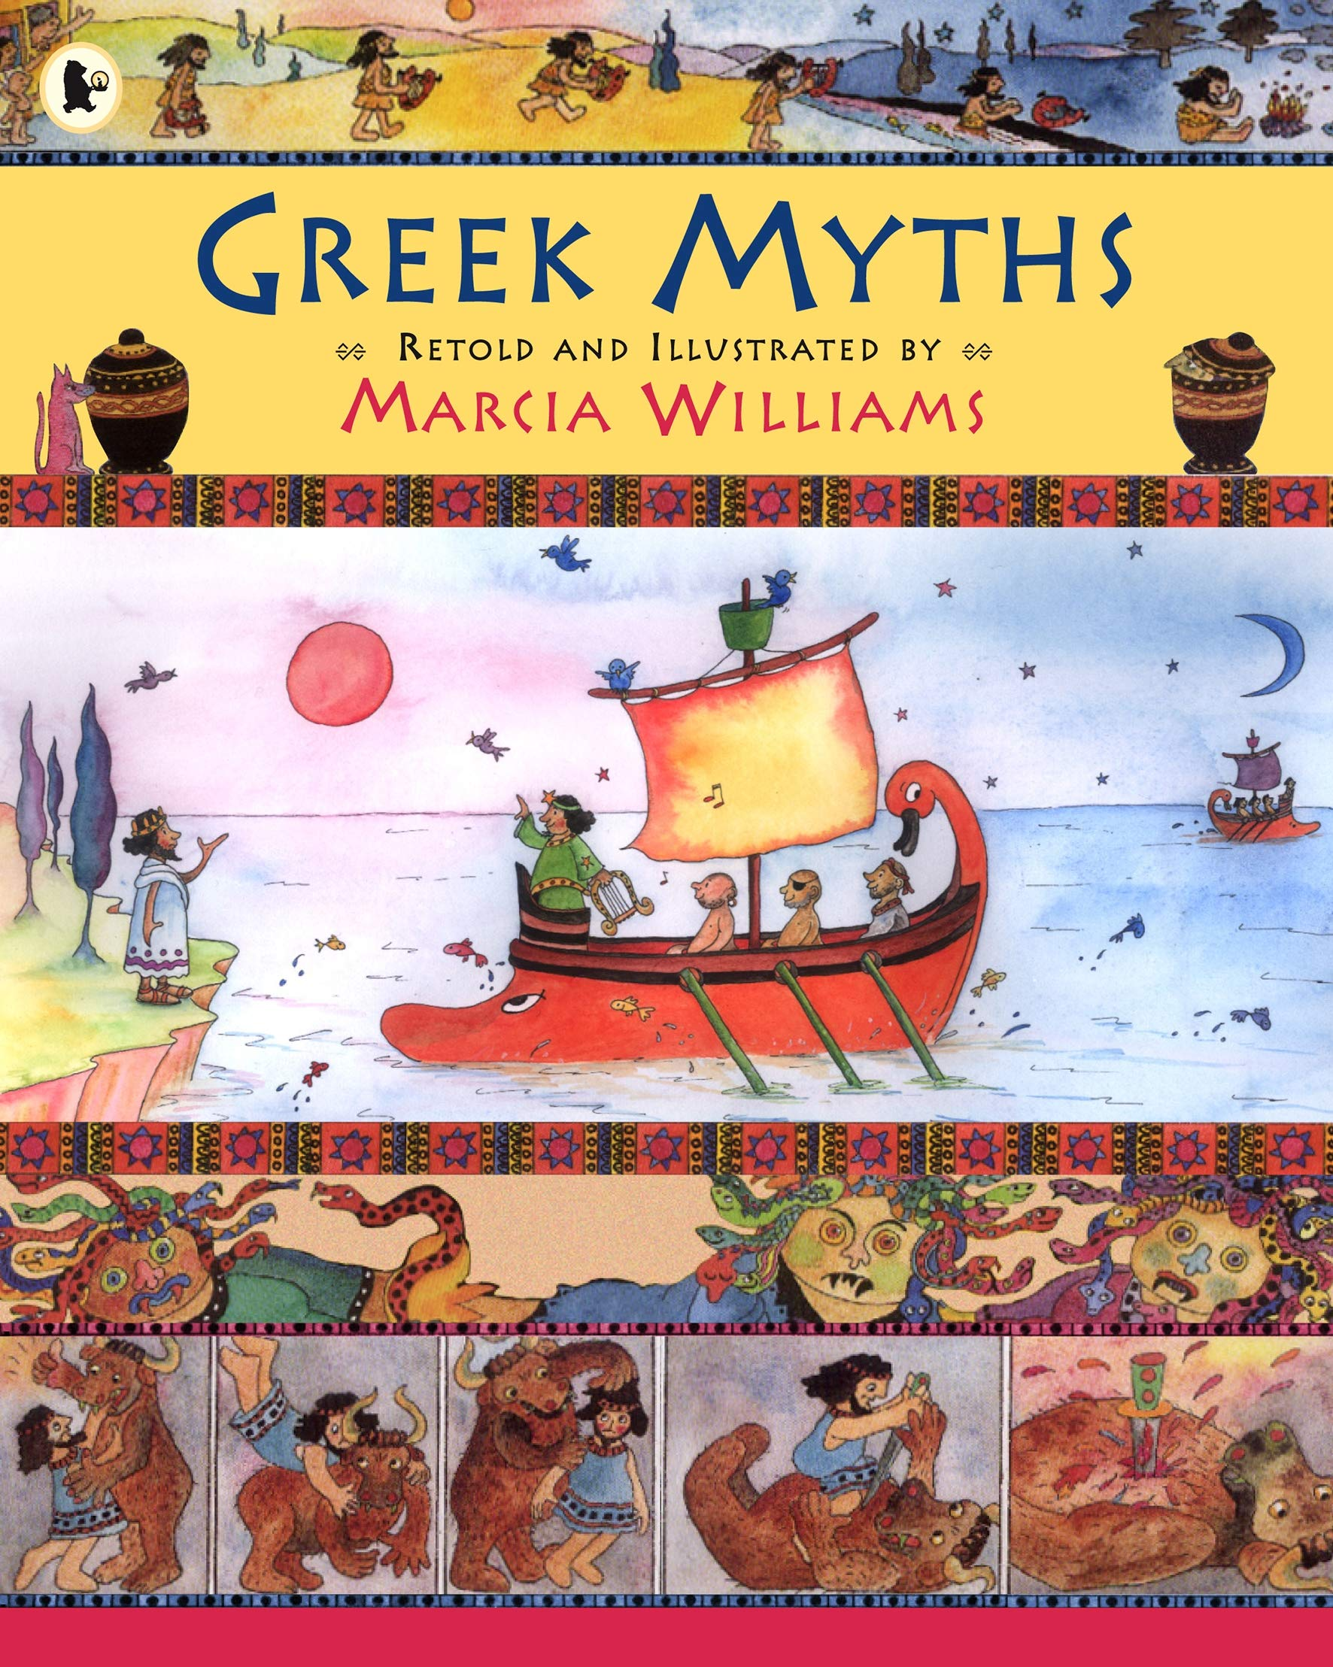

This term our main topic will be Ancient Greece which is a history based unit studying the Greek life and their influence on the western world. The knowledge Organiser gives you more details of the things we will learn.

If you or your child have any interesting books, artefacts or photographs to do with the topic, please send them in to share.