 | DT: Roman Purse
 | Year Group: 4 | Subject Focus: DT | Term: Spring 2
Key Knowledge:  - Understanding Roman Culture: Be able to describe aspects of Roman daily life, focusing on clothing and accessories.  - Design Process: learn the steps of designing a product, from brainstorming ideas to creating a final design for the purse.  - Stitching Techniques: identify and apply basic stitching techniques to create their Roman purse.  Useful and Reliable Websites  - British Museum - Ancient Roman Crafts  - BBC Bitesize - Roman Britain  - History for Kids - Roman Clothing  - National Geographic - Ancient Rome  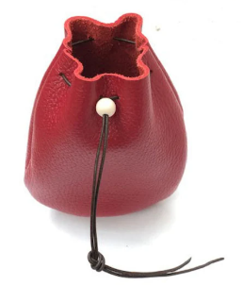  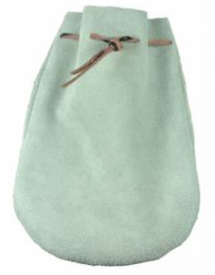 |  | Technical Knowledge:  Roman purses were designed to be functional but would also have a design so that the owner could easily recognise their purse. Leather was used to make the purse because it was hard wearing.  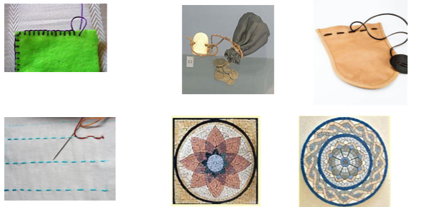  Facts:  - The Romans used a special type of leather called "calfskin" for making purses and bags because it was durable and could be used for many years.  - The average Roman purse was designed to be worn on the belt or the side, making it easy to carry coins, documents, and personal items.  - The Romans were skilled at embroidery, often adding intricate designs to their clothing and accessories.  - Roman soldiers carried small purses for coins while they travelled, which were often made in a simple but effective design for function and convenience. | Key words:  Design: A plan or drawing created to show the look and function of a product before it is made.  Purse: A small bag used to carry coins, money, or personal items.  Stitching: The method of joining pieces of fabric together using a needle and thread.  Material: The substance used to make something, such as leather, fabric, or wool.  Texture: The feel, appearance, or consistency of a surface.  Embroidery: A decorative design made by sewing patterns onto fabric.  Segment: A part or section of something.  Prototype: An early model of a product that is built to test a concept.  Evaluation: The process of assessing a product's effectiveness and suggesting improvements.  Sewing: The activity of using a needle and thread to make or fasten something.  .
?

