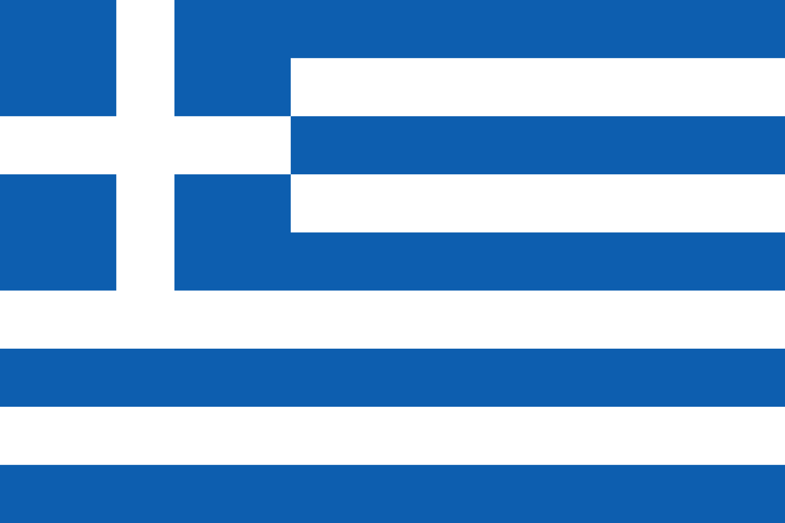 | Greece |  |  | 
 | Year Group: 4 | Subject Focus: Geography | Term: Autumn 2
Key facts  Greece is one of the most mountainous countries in Europe. The highest mountain is Mount Olympus at 2,917m.  Greece contains thousands of islands in the Aegean Sea, Mediterranean Sea and Ionian Sea. The largest island is Crete.  Greece has a warm and sunny climate. The temperature averages around 33°C in summer and 14° in winter.  Rainfall is heaviest in the northern mountains. Some islands receive very little yearly rain.  The longest river entirely in Greece is Haliacmon, which is about 185 miles long.  The population of Greece is around 10.8million. This makes it the fourteenth most populous country in Europe. |  | Greece has a long and rich history, and a culture which has developed over thousands of years from the time of the Ancient Greeks. The warm climate also makes it a popular holiday destination for people from across the world.  Greece is located in the south east of Europe. The capital and largest city of Greece is Athens. Greece borders a number of countries including Bulgaria and Turkey. It also has the longest Mediterranean coastline.  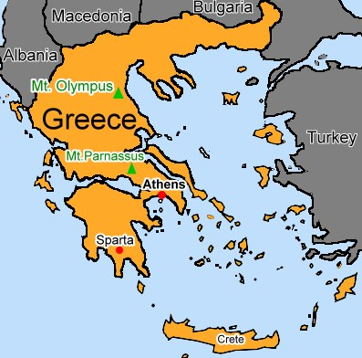 | Key words:  Climate The weather conditions in an area.  Population The number of people living in a certain area  Currency A system of money in general use in a particular country.  Europe Europe is a continent located entirely in the Northern Hemisphere.  Geographical regions A part of a country or the world having definable characteristics but not always fixed boundaries.  Hemisphere A half of the earth, usually divided by the equator into the northern and southern hemisphere  Export Sending goods to sell in other countries  Four figure grid referencing Used to pinpoint a location within a square  Topographical feature The physical features of an area of land  Tourism The commercial organisation and operation of holidays and visits to places of interest.
Exciting books/ web links:
- Facts all about Greece

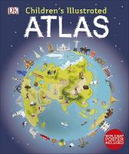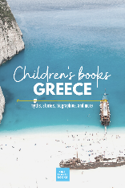
Did you know?  - Greek is the official language spoken in Greece.  - Lake Trichonida is the largest lake in Greece. It is located north of the city of Patras.  - Greece is the third largest olive oil producer in the world – after Italy and Spain. |  | Parents as partners:  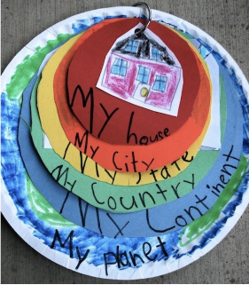  - Can you research what foods come from Greece and try these?  - Design a brochure to encourage people to visit Greece.  - Using a few paper plates, design a multilayer masterpiece that depicts your place in the world. Each circle represents a different geographical location; planet, continent, country, city etc.
Comparison with the UK
Both countries are in Europe; the UK is in northern Europe and Greece is in southern Europe.
Due to Greece being closer to the Equator, it is warmer than the UK.
Significantly more people live in the UK – 66 million compared to 10.8 million.
Greece has higher mountains than the UK. Mount Olympus is 2,917m and Ben Nevis in the UK is 1,345m.

