 | DT: Slingshot Car
 | Year Group: 4 | Subject Focus: DT | Term: Autumn 2
Key Knowledge:  - To understand that all moving things have kinetic energy.  - To understand that kinetic energy is the energy that something (object/person) has by being in motion.  - To know that air resistance is the level of drag on an object as it is forced through the air.  - To understand that the shape of a moving object will affect how it moves due to air resistance.  Which vehicle do you think has the least air resistance?  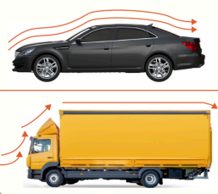 |  | Technical Knowledge:  - Mechanisms are a system of parts that work together to create a motion.  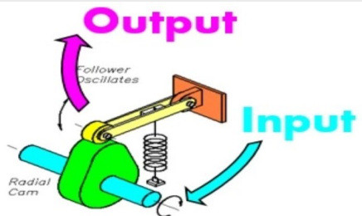  - There is input and output in a mechanism.  - Axles help wheels to move a vehicle.  Front View  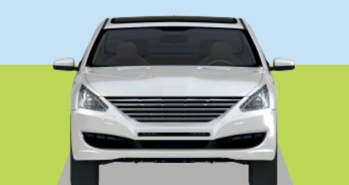  Side View  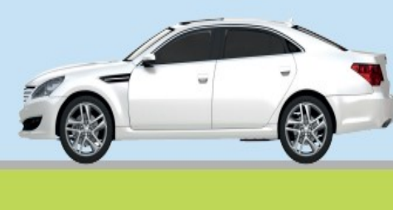  Bird’s-eye View  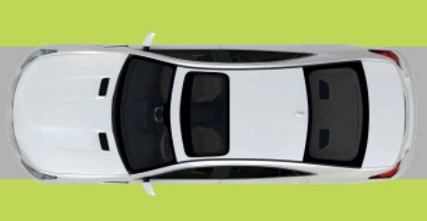 | Key words:  Axel A bar with wheels that turns  Chassis The body of a car.  Air Resistance The level of drag on an object as it is forced through the air.  Design To make, draw or plan for something.  Slingshot A Y-shaped toy used with an elastic band to shoot.  Function The purpose of an object or how the product works.  Kinetic Energy The energy that causes an object to move  Mechanism The parts of an object that move together as part of a machine.  Net A flat 2D shape, that can become a 3D shape once assembled.  Structure Something that has been made and put together and can usually stand on its own.  .  Real life:  Did you know?    Some of the first toy cars were made in 1901, that’s over 100 years ago!
?

