 | Art: Drawing
 | Year Group: 4 | Subject Focus: Art | Term: Autumn 1
Skills:  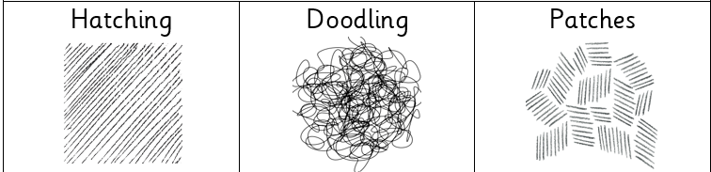  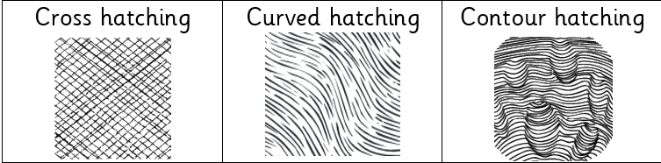  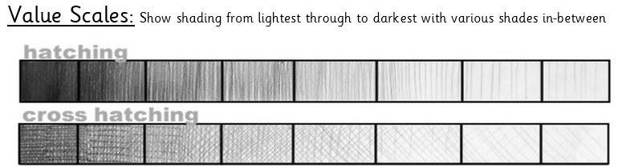  Tone to add definition:  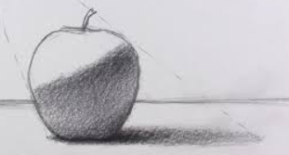  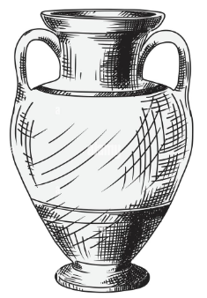  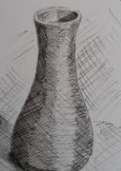 |  | Famous Artwork:  Henri Matisse, Open Window  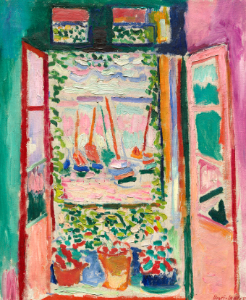  Wassily Kandinsky, Farbstudie Quadrate  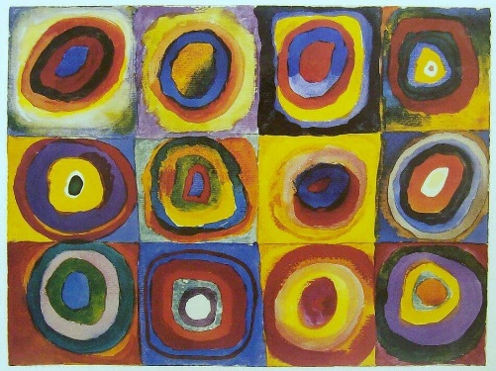  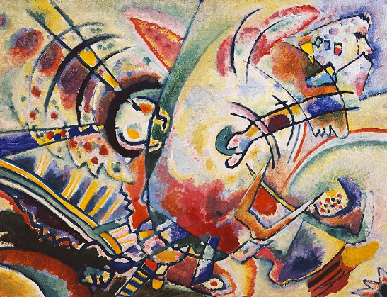  Wassily Kandinsky, Non-Objective | Key words:  Cross hatching Adding straight, parallel lines, which face in a different direction, over hatching.  Contour hatching Similar to regular hatching, but the lines will follow the curves or outline of the subject matter  Curve Hatching Small lines which are not straight.  Hatching used to create tonal or shading effects by drawing (or painting or scribing) closely spaced parallel lines  Blending Rubbing or smudging to create a gradual transition to soften lines.  Tone / Tonal Providing a range of light to dark by shading with pencil.  Proportion The different sizes of the individual parts that make up one object.  Pressure The amount of force applied- this will determine the darkness of the piece.  Technique Various methods used by Artists to create artworks.  Precision To be exact and use accuracy  About the artists:  HENRI MATISSE  - Henri Matisse was born on December 31st, 1869.  - He was a French artist and is recognised as one of the leading figures in modern art.  - Matisse and Picasso were very good friends and were often compared.  WASSILY KANDINKSY  - Wassily Kandinsky was born in 1866 in Moscow, Russia.  - He is well-known for creating abstract paintings which were inspired by music  - Kandinsky had a rare condition called synaesthesia where he saw colours when he heard music and heard music when he painted.

