Year 3 Newsletter (Summer 1)

Welcome back to Year 3 - Edmondson class! I hope you had a lovely Easter holiday. As we embark into our final term, get ready for a wealth of learning experiences and engaging projects.
Our learning journey
Our Geography unit for this half term will be exploring Leeds.  We will locate Leeds on a map and learn the geographical facts about Leeds. We will research and locate landmarks and physical features in Leeds using 4-point grid referencing. We will finish the unit by planning a journey to a local landmark in Leeds using compass points and grid referencing.  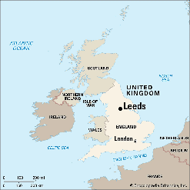 | In Science, we will we will focus on Plants.  The children will learn the different parts of a flowering plant and be able to explain their jobs. They will set up investigations to find out what plants need to grow, developing their working scientifically skills. Children will also investigate how water is transported in plants. They will be able to explain the role of pollination and fertilisation. We will finish the unit by understanding and ordering the stages of the life cycle of a flowering plant.   | In our Maths lessons, we will focus on fractions, understanding how to add and subtract fractions. We will also explore the concept of addition and subtraction with money. We will then develop our understanding of pounds and pence and how to convert between both units. We will then finish the half term learning about time, being able to the tell the time to the minute as well as being able to use AM and PM. We will also look at understanding roman numerals to 12.  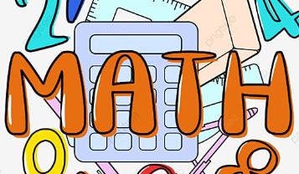 | In English, we will begin by writing a sequel to a traditional tale – Jack and the Beanstalk.  We will then focus on writing a persuasive leaflet about visiting Leeds, linking to our learning on Leeds in Geography. We will explore key genre and grammar features of a persuasive text in order to entice the reader into visiting Leeds.  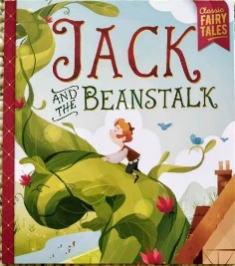  We will finish the half term by exploring different poets. We will work on reciting these famous poems and performing them.

Diary Dates:  PE will take place on a Monday and Tuesday. Children need to come to school in their uniform on these days and bring the full PE kit. They will also need a water bottle.  . | Class routines:  - The children are expected to read at home every night. Reading records and books should be brought to school every day so that a member of staff can read with them in school. These reading books will be changed on a Friday if the reading record has been signed.  - Each Friday, the children will complete a spelling quiz. The spellings focus will be sent home on a Friday, ready to learn for the following Friday. The children will need to practise these at home (and at school) on a regular basis.  - Pupils should continue to log onto TTRockstars to improve their times tables knowledge.
Finally, please remember to log onto the class page on the school website to keep up to date with our latest news: https://www.crossgatesprimary.co.uk/class-pages/ or by accessing the school twitter page.
Mr Doonan

