 | Plants |  |  | 
 | Year Group: 3 | Subject Focus: Science | Term: Summer 1
Key facts  - Many plants, but not all, have roots, stems/trunks, leaves and flowers/blossom.  - The roots absorb water and nutrients from the soil and anchor the plant in place.  - Leaves use sunlight and water to produce the plant’s food. Some plants produce flowers which enable the plant to reproduce.  - Different plants require different conditions for germination and growth. |  | Our Learning Journey:  We Are Learning To…  name the different parts of flowering plants and explain their jobs.  Set up an investigation to find out what plants need to grow well.  Investigate how water is transported in plants.  Name the different parts of a flower and explain their role in pollination and fertilisation.  Understand and order the stages of the life cycle of a flowering plant.  Our five enquiry types:  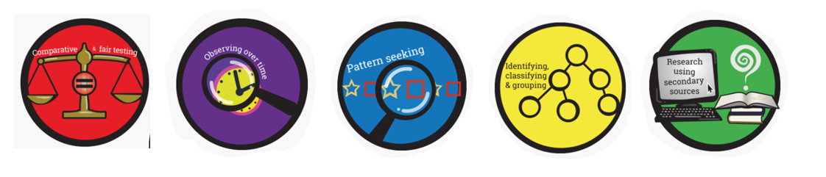  Working Scientifically Skills:  In this unit we will be:    Asking Questions    Making Predictions    Observing    Interpreting and Communicating Results    Evaluating | Key words:  photosynthesis Photosynthesis is the process by which plants convert sunlight into energy  pollen A powder produced by plants that causes plants to form seeds.  Insect pollination The transfer of pollen by insects.  Seed formation When a seed is produced.  Seed dispersal The movement of seeds by wind, animals, etc.  Wind dispersal The transfer of seeds by wind.  Animal dispersal The transfer of seeds by animals.  Water dispersal The movement of water.  Water what plants needs to survive.  Flower The seed-bearing part of a plant.  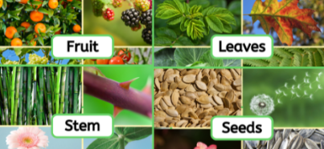
Key people
- Captain Cook – English naturalist and botanist
- Agnes Arber – British botanist
- Alan Titchmarsh – British botanist & gardener

Exciting books/ web links:
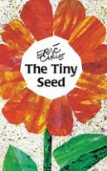
The Tiny Seed – Eric Carle.

Jasper’s Beanstalk – Nick Butterworth.

A Seed is Sleepy – Diana Aston & Sylvia Long
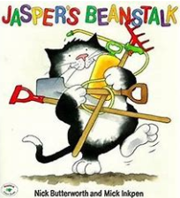
Parents as partners:
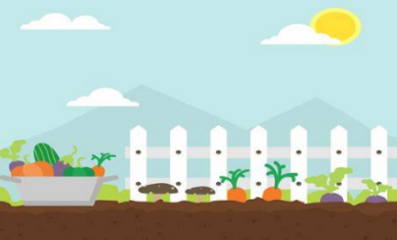
- How many different kinds of plants are there near where you live? How about in your home or garden?
- Which parts of your dinner came from plants? Can you draw and label a picture?
- What if there were no plants? Could you draw a picture of what life would look like?

