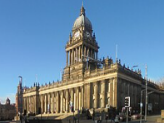 | Leeds (Mapping) |  |  | 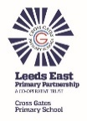
 | Year Group: 3 | Subject Focus: Geography | Term: Summer 1
Key facts  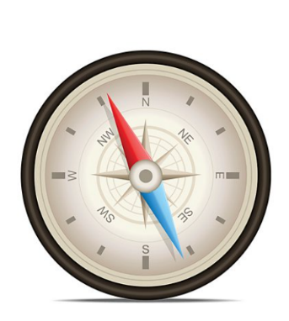  - Here are the two ways to memorise the compass points for North (N), East (E), South (S) and West (W).  - Naughty Elephants Squirt Water  - Never Eat Sugar Worms  - Leeds is a city in West Yorkshire, England.  - It is the largest settlement in Yorkshire.  - It is built around the River Aire and the Eastern foothills of the Pennines.  - The Aire Valley is about 63m above sea level, with the mountains of the Pennines ranging up to 340m in the area of Ilkley Moor. |  | Parents as partners:  Could you take a trip into Leeds and make a list of all the key landmarks that you see?  Could you create and draw your own map of Leeds or your local area? Remember to label it with all the key features!  Exciting books/ web links:  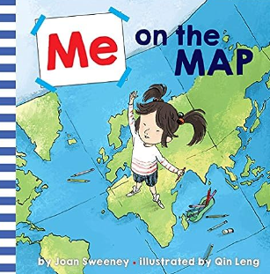  Me on the Map by Joan Sweeney.  A bright and colourful book which teaches children lots of new skills and information about maps.  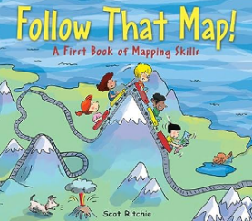  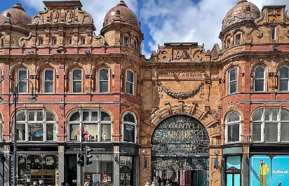  Follow that Map! A First Book of Mapping Skills.  Leeds England Travel Guide: 15 BEST Things To Do In Leeds, UK (youtube.com) | Key words:  map A drawing which shows where things are.  compass A tool for finding direction.  geographical The geography of a specific area. The geographical features may include, rivers, hills, etc.  landmark Features around the world which are easily recognised.  perspective The way in which you see something.  observe To watch or listen to something carefully.  fieldwork Going outdoors and finding things out about a place.  key Features around the world which are easily recognised.  local An area which you live.  symbol A picture used to show a feature on a map.

Key people/ places
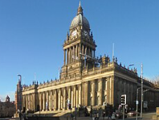
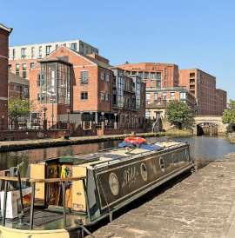
Leeds Town Hall- A reminder of Leeds as a centre of trade and commerce.
Leeds Docks-
Presented by the River Aire. You can even travel by a water taxi!
