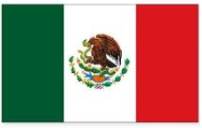 | Mexico |  |  | 
 | Year Group: 2 | Subject Focus: Geography | Term: Summer 2
Key facts  - Mexico is a country in the continent of North America and the main language is Spanish.  - The capital city is called Mexico City.  - The flag is green, white and red with an eagle in the middle.  - Mexico is very close to the Equator, so the weather is hot all year round. It only has two seasons – rainy and dry.  - The rainy season is May until October and then there is very little rain for the rest of the year. This makes it a lovely place to go on holiday.  - Mexico is almost completely surrounded by sea and so has lots of beautiful beaches. The Pacific Ocean is on the South and West side of Mexico. The Caribbean Sea is on the East side.  - There are thick, green forests in parts of Mexico, but there are also deserts.  - There is a volcano in Mexico which is dormant, and it is the highest mountain in Mexico.  - Lots of Mexican people now live in the USA and go there for work therefore Spanish is spoken a lot in America too.  - The food in Mexico is very famous; it is hot and spicy and uses lots of chilies… but did you also know that chocolate, avocados and corn all come from there? |  | Parents as partners:  - Go to the travel agents and see if they can give you a brochure about Mexico. Can you find out where it is in the world? Is it North, South, East or West from Cross Gates?  - Can you find out about any famous people from Mexico?  - What sorts of things do you think might be the same or different about living in Mexico to Cross Gates? Make a list of your ideas and we will find out!  - Look in your food cupboards – do you have food from different parts of the world? What makes them different? Have you tasted any Mexican foods before?  Exciting books/ web links:  https://kids.nationalgeographic.com/explore/countries/mexico/  https://www.bbc.co.uk/bitesize/clips/znbkq6f  https://www.youtube.com/watch?v=7tWAGdBbMRQ  https://www.youtube.com/watch?v=n6gBwaX4u_U  https://www.youtube.com/watch?v=x81JdbzbdJ4 | Key words:  climate The usual weather conditions of a certain place or region.  compare To describe the similarities and differences between two or more things.  desert A waterless area of land with little or no vegetation, typically covered with sand.  Equator The imaginary circle around the earth that is halfway between the North and South Poles.  volcano A hill or mountain where melted or hot rock and steam comes out.  Spanish The language spoken in Mexico.  tropical Parts of the world nearest to the equator are known as tropical.  valley A long area of low land between mountains or hills, a river or stream usually runs through it.  vegetation Plants or plant life in a particular place.  North America and South America The two continents shown in the map below. Mexico is in North America, but is close to South America.

Key places
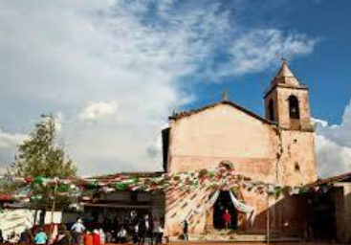

Tocuaro is a small village near Lake Pátzcuaro in the Mexican state of Michoacán. In our study unit, we will be comparing Tocuaro to Cross Gates.
