[](https://www.google.com/url?sa=i&rct=j&q=&esrc=s&source=images&cd=&cad=rja&uact=8&ved=2ahUKEwjHxIjj8bvaAhUHtxQKHT_qAbkQjRx6BAgAEAU&url=https://www.mycutegraphics.com/graphics/kids/happy-children.html&psig=AOvVaw3rHk4aLq7akbrSXyU8HnRd&ust=1523868246573925)**Year 2 Summer 2 Newsletter**

We would like to welcome everyone back.

Year 2 continue to enjoy our learning as well as developing our skills and knowledge.

In **Maths**, we will be continuing our learning on Fractions and we then will begin to look at Time.

In **English,** we are using the book ‘Flat Stanley’ to write a character description. We will also be writing a letter to Flat Stanley.

In **Science,** our unit of study is ‘Living Things and Their Habitats’. We will be continuing discovering where plants and animals have their natural habitats.

In **Music,** we will be looking at beats and tempo through the use of singing games. **PSHE** sees us learning about keeping ourselves safe. In **RE,** we will be learning about how symbols are used to welcome new life.

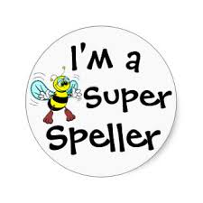In **Design and Technology,** we will be learning about a balanced diet and we will be making wraps. In **Computing,** we will be presenting ideas digitally and in **French**, we are going to continue learning nursery rhymes.

We will continue to work with our coach in **PE**. We would like to remind you again that our PE days are Monday and Tuesday and it is your responsibility to provide your child with a PE kit, including pumps, that is in school on those days. We would also request that, in line with school policy, any earrings are removed on these days.

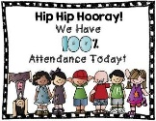The children will continue to bring home spellings each week, usually on a Friday, that they will need to learn for a test the following Friday. We always appreciate your support with helping your child learn their spellings.

Your child’s **attendance**, as always, is very important. Children can find it difficult to keep up with their work if their attendance is not consistent. Obviously, genuine illness is a different matter.

If you would like to know anything regarding your child in Year 2, please do not hesitate to contact us. We would like to thank you for your continued support.

Miss Ali and the Year 2 Team