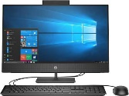 | Significant Individuals in Medicine- Florence Nightingale and Mary Seacole |  |  | 
 | Year Group: 2 | Subject Focus: History | Term: Spring 2
Key facts  - Florence Nightingale was born in 1820 in a big city in Italy called Florence. That is how she got her name.  - She became known as the ‘Lady with the Lamp’.  - Florence Nightingale is remembered for showing people that nursing is a very important job.  - In the 1800s there was no medicine to stop infections killing people!  - Mary Seacole was British-Jamaican, born in 1805.  - Mary grew up in her mother’s hotel in Jamacia. Mary had lots of experience caring for sick British soldiers.  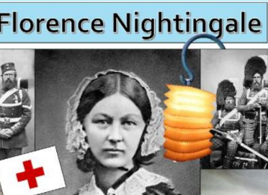  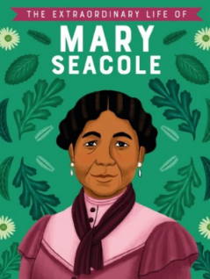  - She used her medical knowledge and looked after wounded soldiers from the battlefield. |  | Parents as partners:  - The Thackery Medical Museum has lots of interesting exhibits regarding medicine in the past.  Exciting books/ web links:  Who was Florence Nightingale? - BBC Bitesize  Who was Mary Seacole? - BBC Bitesize  Florence Nightingale facts for kids | National Geographic Kids (natgeokids.com)  Mary Seacole Facts for Kids | National Geographic Kids (natgeokids.com)  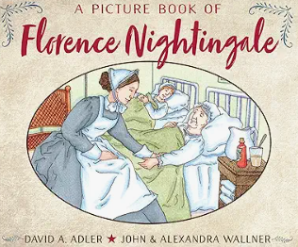  A picture book of Florence Nightingale  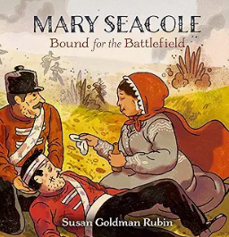  Mary Seacole: Bound for the Battlefield | Key words:  achievement a thing done successfully with effort, skill, or courage  chronology the arrangement of events in the order they happened  Crimea Located on the peninsula of Ukraine lying between the Sea of Azov and the Black Sea.  era a long and distinct period of history  famous known about by many people  first hand directly experienced by somebody  impact the result an action has.  medicine What makes people better- often liquids or tablet form.  society the community of people living together.  soldiers people who fight in battles or wars.  - Could you child design and draw a fact-file all about either Mary Seacole or Florence Nightingale?
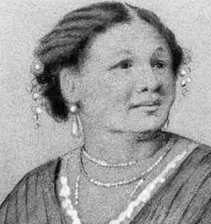
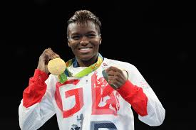
Key people/ places

Mary Seacole

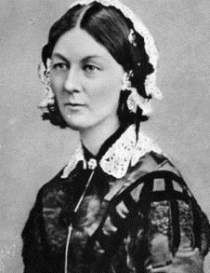

Florence Nightingale

Crimea- This was where the Crimean War took place. Mary Seacole and Florence Nightingale both looked after the wounded soldiers.

We Are Learning To:
- Know who Florence Nightingale was and why she is famous.
- Know who Mary Seacole was and why she is famous.
- Compare the achievements of Mary Seacole and Florence Nightingale.
- Understand the impact Mary Seacole and Florence Nightingale had on today’s society.

