 | Animals Including Humans |  |  | 
 | Year Group: 2 | Subject Focus: Science | Term: Autumn 1
Key facts  - Animals need food, water and air in order to survive.  - Humans need a varied, balanced diet including water and lots of fruit and vegetables to stay healthy. They also need regular exercise and to wash regularly in order to stay hygienic and healthy.  - Animals have offspring that grow into adults. |  | 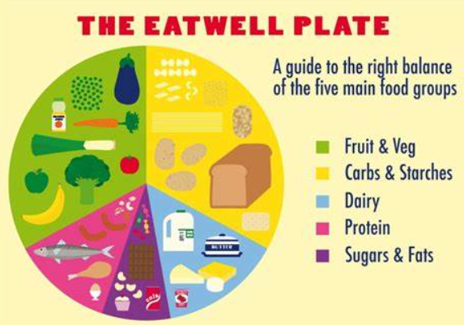  The Eat-Well Plate is a guide to the right balance of the five main food groups. These are fruit and vegetables, carbohydrates, dairy, protein and then fat.  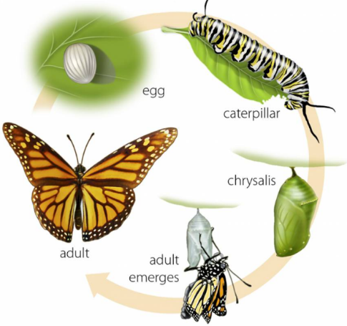  A key piece of learning we will carry out is the life cycle of a butterfly.  A butterfly lays an egg, a caterpillar emerges from the egg, the caterpillar pupates in a chrysalis and butterfly emerges from the chrysalis. | Key words:  adult A person who is fully grown.  baby A very young child.  breathing Air passing in and out of the lungs.  disease A condition that stops the proper function of the body.  exercise Physical activity for fitness.  germs Tiny organisms that can cause disease.  growth An increase in size.  hygiene Keeping your body clean.  offspring The young version of a parent.  reproduction To have babies.
Key people
Florence Nightingale - Pioneer of modern nursing in Britain
Elizabeth Garrett Anderson - First British female physician and surgeon
Steve Irwin – Australian wildlife expert
Robert Winston – British human scientist

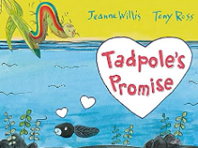
Exciting books/ web links:
Tadpole’s Promise – Jeanne Willis.

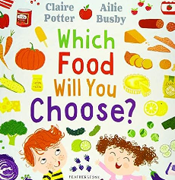
Monkey Puzzle – Julia Donaldson.
Once There Were Giants – Martin Waddell.

Which Food Will You Choose? – Claire Potter.
Parents as partners:
At home you can complete lots of different activities you can complete to support your children learning.
Could your child write a set of instructions/recipe for a healthy snack or meal, such as a salad, soup or pizza?

