 | Living things and their habitats |  |  | 
 | Year Group: 2 | Subject Focus: Science | Term: Summer 2
Key facts  - Living things can be divided into two main groups: plants and animals.  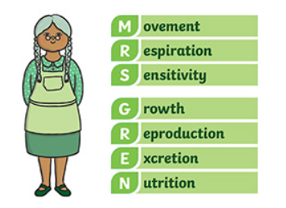  - Habitats are where something lives- these have to be suitable for the animal or human.  - MRS GREN- the seven life processes are: |  | Our Learning Journey:  We Are Learning To…  - identify and name a variety of plants and animals in their habitats, including micro habitats.  - explore and compare the differences between things that are living, dead and things that have never been alive.  - identify that most living things live in habitats to which they are suited and describe how different habitats provide for the basic needs of different kinds of animals and plants and how they depend on each other.  Our five enquiry types:  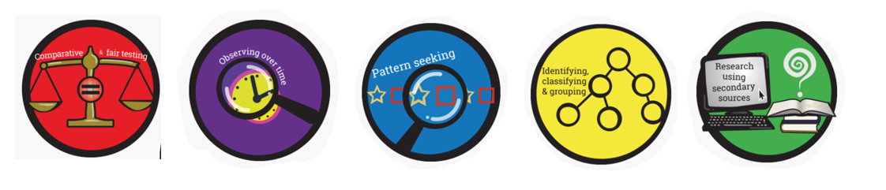  Working Scientifically Skills:  In this unit we will be:    Asking Questions    Making Predictions    Observing    Interpreting and Communicating Results    Evaluating | Key words:  air What we breathe in and an important part of survival- all animals and humans need it.  dead No longer alive. For example, the dead tree was grey and leafless.  food An important part of survival- all animals and humans need it.  food chain A series of living beings in which each serves as food for the next.  living To be alive and breathing.  never been alive To have never had life or have been living.  suitable Right for the situation or purpose. For example, “I wanted to buy him a suitable going away gift”.  shelter A place giving protection from bad weather or danger.  survive To remain alive.  water An important part of survival- all animals and humans need it.
Key people

Steve Irwin – Australian wildlife expert.
Robert Winston – British human scientist.
Exciting books/ web links:
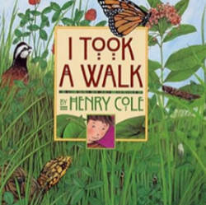
‘I Took a Walk’ by Henry Cole.
This is a beautifully illustrated introduction to British wildlife and habitats.

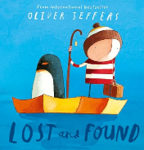
‘Lost and Found’ by Oliver Jeffers.

Make a bug hotel! https://www.bbc.co.uk/cbbc/thingstodo/bp-bug-mansion-make

Take the quiz…
https://www.bbc.co.uk/bitesize/articles/zs73r82
Parents as partners:
My Habitat - Living, Dead or Never Alive: can your child choose and sort objects from their homes and gardens into categories depending on whether they are living, dead or have never been alive?
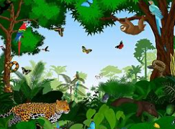
Garden Food Chain: can your child make up their own food chain from living things that can be found in their garden or a nearby park?

