 | Plants |  |  | 
 | Year Group: 2 | Subject Focus: Science | Term: Spring 2
Key facts  - Plants need water, light and a suitable temperature to grow.  - Plants can grow from seeds or bulbs.  - As a seed germinates, the roots grow downwards first then a shoot grows upwards.  - Water and nutrients are absorbed through a plant’s roots. |  | Our Learning Journey:  We Are Learning To…  Identify and describe the basic structure of variety of common flowering plants, including trees.  Observe and describe how seeds and bulbs grow into mature plants.  Find out and describe how plants need water, light and a suitable temperature to grow and stay healthy.  Our five enquiry types:  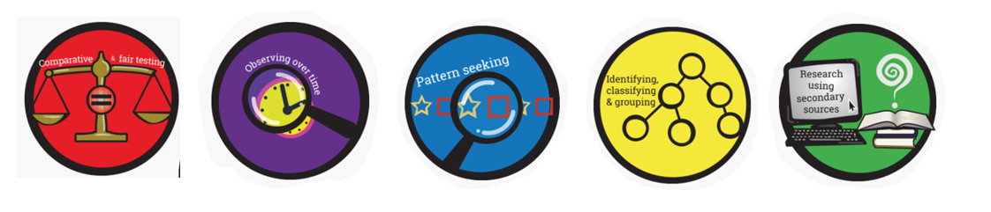  Working Scientifically Skills:  In this unit we will be:    Asking Questions    Making Predictions    Observing    Interpreting and Communicating Results    Evaluating | Key words:  bulb an underground seed which stores the life-cycle.  cool a colder or cooler temperature.  germinate when a seed begins to grow and put outs shoots.  grow increasing in size and changing physically.  light the natural light to make things visible (you can see!)  seedling a young plant raised from a seed.  shoot a young branch from the main of a tree or plant.  space an area which is free.  shade coolness and darkness caused by shelter away from the sun.  warm a high temperature.  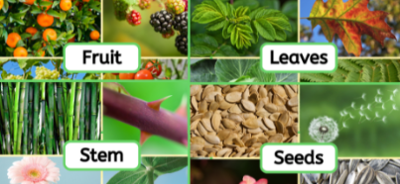
Key people
- Captain Cook – English naturalist and botanist
- Agnes Arber – British botanist
- Alan Titchmarsh – British botanist & gardener

Exciting books/ web links:
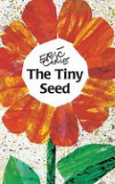
The Tiny Seed – Eric Carle.

Jasper’s Beanstalk – Nick Butterworth.

A Seed is Sleepy – Diana Aston & Sylvia Long

Parents as partners:
- How many different kinds of plants are there near where you live? How about in your home or garden?
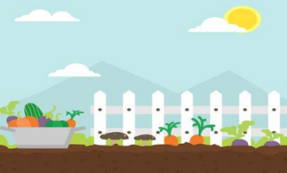
- Which parts of your dinner came from plants? Can you draw and label a picture?
- What if there were no plants? Could you draw a picture of what life would look like?

