 | Animals including humans |  |  | 
 | Year Group: 2 | Subject Focus: Science | Term: Spring 1
Key facts  - Animals need food, water and air in order to survive.  - Animals have offspring that grow into adults  - A chicken lays an egg, a chick emerges from the egg and grows into a chicken.  - A butterfly lays an egg, a caterpillar emerges from the egg, the caterpillar pupates in a chrysalis and butterfly emerges from the chrysalis.  - A human gives birth to a baby, a baby grows into a toddler, a toddler grows into a child and a child grows into an adult.  - A frog lays frogspawn, a tadpole grows inside the frogspawn, the tadpole emerges from the frogspawn, the tadpole develops into a frog. |  | Our Learning Journey:  We Are Learning To…  Find out about and describe the basic needs of animals, including humans for survival.  Notice that animals, including humans, have offspring which grow into adults.  Find out about and describe the basic needs of animals, including humans, for survival (water, food and air).  Our five enquiry types:    Working Scientifically Skills:  In this unit we will be:    Asking Questions    Making Predictions    Observing    Interpreting and Communicating Results    Evaluating | Key words:  adult an animal or human which is fully grown and developed.  air what we breathe in.  grow to naturally change in size and look physically different.  growth to increase in size by a natural process.  life cycle the series of changes in life- from baby all the way to adult.  survive to remain alive.  survival the act of surviving, especially in difficult circumstances.  off-spring an animal or human’s child.  young being in the first or early stages of life.  water an important part of survival- all animals and humans need it.  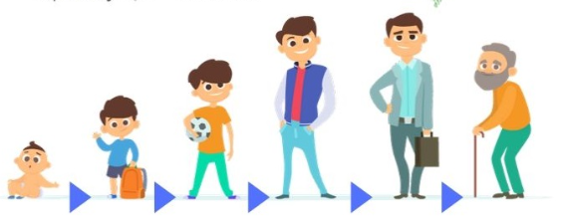  The Human Life Cycle
Key people
Florence Nightingale - Pioneer of modern nursing in Britain.
Elizabeth Garrett Anderson - First British female physician and surgeon.
Steve Irwin – Australian wildlife expert.
Robert Winston – British human scientist.

Exciting books/ web links:
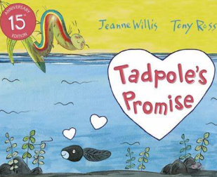
Tadpole’s Promise – Jeanne Willis

Monkey Puzzle – Julia Donaldson

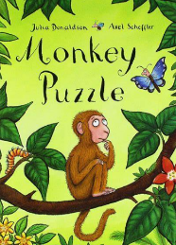
Once There Were Giants – Martin Waddell

Tad – Benji Davis

Parents as partners:
Could you visit a local farm, ideally more than once to allow children to observe changes in animals over time?
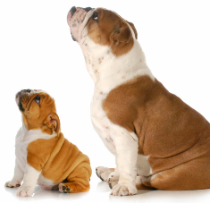
Do you have any pets? How have they changed over time? How are they different, could your child draw a picture?

