 | Uses of everyday materials |  |  | 
 | Year Group: 2 | Subject Focus: Science | Term: Autumn 2
Key facts  - Materials can have a number of different properties. They are chosen for various uses based on their properties.  - Materials can be hard or soft, shiny or dull, rough or smooth, flexible (bendy) or rigid (not bendy), waterproof or permeable and opaque, translucent or transparent. |  | Our Learning Journey:  We Are Learning To…  Investigate what we already know about every day materials- linking back to our Year 1 learning.  Identify materials of different objects.  Investigate how solid objects can be altered to change their suitability for a purpose.  Identify the use of everyday materials and their suitability.  Our five enquiry types:  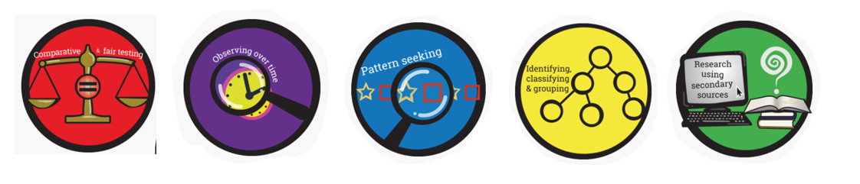  Working Scientifically Skills:  In this unit we will be:    Asking Questions    Making Predictions    Observing    Interpreting and Communicating Results    Evaluating | Key words:  flexible Bending easily without breaking.  material The substance to make something.  property The qualities which a material has. This could be, hard, soft, flexible, strong, etc.  rigid Unable to bend or forced out of shape.  rough Having an uneven surface, the opposite of smooth.  smooth Having an even surface with no bumps or lumps. The opposite of rough.  transparent Letting light pass through and giving a clear view of objects at the other side. For example, windows.  use What purpose objects serve.  opaque Not letting light pass through. For example, if transparent materials let light through (such as windows), opaque surfaces do not (for example curtains).  waterproof Not letting water through.  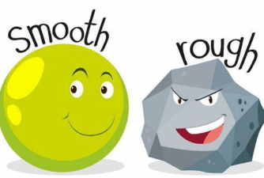  Transparent Opaque  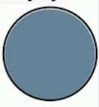  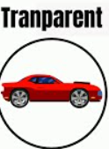
Key people
William Addis – Toothbrush inventor
Charles Mackintosh – Invented the waterproof coat, Mackintosh raincoat named after him
John MacAdam-Roads Chester – invented earmuffs.
Exciting books/ web links:

Centrally Heated Knickers – Michael Rosen (poetry book)

Little Lumpty – Miko Imai

Santa is Coming to Leeds – Steve Smallman

Aliens Love Underpants – Claire Freedman
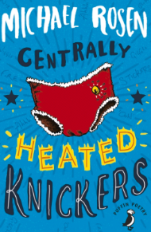
The Three Little Wolves and the Big Bad Pig – Eugene Trivisas
Parents as partners:
Could your child investigate what material their toys/clothes are made out of?
What is their favourite material? What properties does it have?
What different materials can you find in your home?
Imagine a world without wood/metal/plastic, could your child draw what their life may look like?

