 | Map makers |  |  | 
 | Year Group: 2 | Subject Focus: Geography | Term: Autumn 1
Key facts  - Maps can be drawings or models. They can help you find where you are and where you are going.  - They show symbols (pictures) for places such as car parks, shops, etc.  - They also have a key which tells you what the symbol means.  - Maps can help you find your way using directions. You can use a compass to find which direction you are facing. |  | Map reading tips!  - It’s important to hold maps the right way so that you know which way, or direction to go.  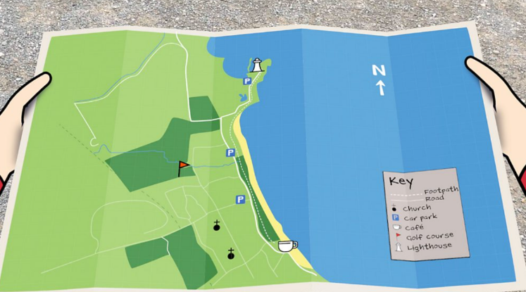  - You can work out where you are on a map by looking at things around you and finding where they are on the map.  Here are two ways to memorise the compass points for north (N), east (E), south (S) and west (W):  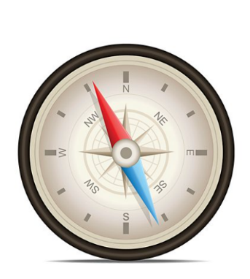  - Naughty Elephants Squirt Water  - Never Eat Sugar Worms | Key words:  aerial A photograph from the air.  axis A straight line when drawing a graph.  compass A tool for finding direction.  fieldwork Going outdoors and finding things out about a place.  key A guide which explains what the symbols on a map mean.  landmark Features around the world which are easily recognised.  local An area which you live.  map A drawing which shows where things are.  observe To watch or listen to something carefully.  perspective Looking at different places, cultures and environments and how they are different.  symbol A picture used to show a feature on a map.
Key people
- The first known map was scratched on clay tablets in 600BC. The first world map was created by Anaximander.
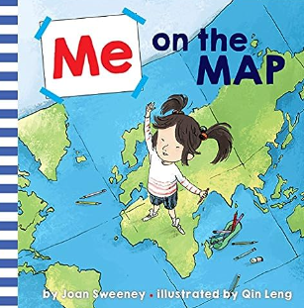
Exciting books/ web links:
Me on the Map by Joan Sweeney.
A bright and colourful book which teaches children lots of new skills and information about maps.

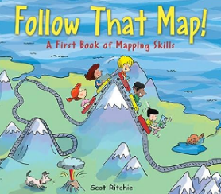

Follow that Map! A First Book of Mapping Skills.
Parents as partners:
Make a map of your living room! Children will learn mapping skills by working on mapping a small space that they know well.
Way Finding – take a map of your local trails or roadways out on an excursion. Have the children try to follow or locate your position on the map and make their way back again by following the map.

