 | DT: Textiles - pouches
 | Year Group: 2 | Subject Focus: DT | Term: Autumn 2
Key facts:  Sewing is good fun. Once you learn how to thread a needle and do a simple running stitch, you can make anything.  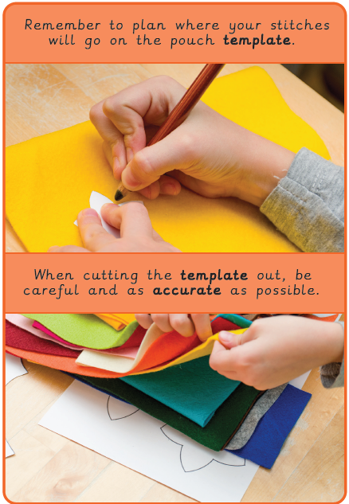 |  | Sewing is an important skill. Our clothes are usually sewn by machine but some are sewn by hand. Can you think of anything else that might be sewn?  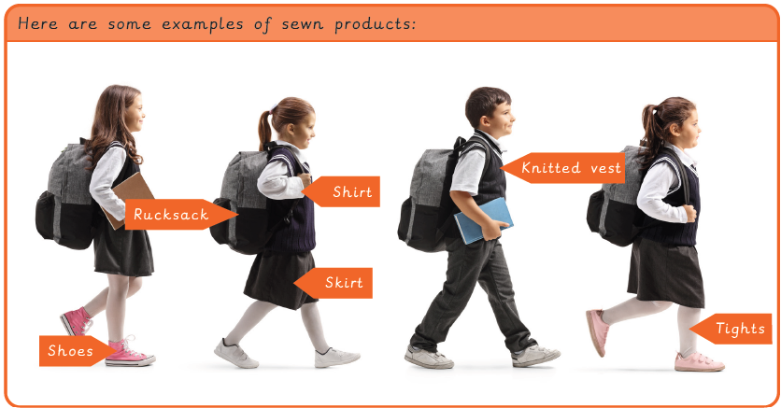  Top Tip:  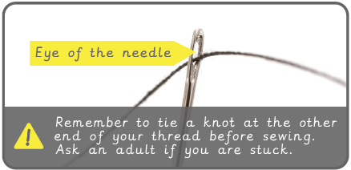 | Key words:  decorate Make something look more attractive by putting things on it.  fabric A natural, man-made or woven or knitted material.  fabric glue A special glue that sticks fabric together.  knot A join made by tying 2 pieces of string or rope together.  needle A thin pointed metal object with a small hole at one end for thread which is used in sewing.  needle threader A small sewing tool which helps to pull the thread through the needle.  running stitch A simple style of sewing in a straight line with no overlapping.  sew To join or fasten by stitches made using a needle and thread.  template A stencil which you use to help you draw a shape more easily on to different materials.  thread A length of a very thin fibre.  .  Real life: End results!  