 | DT: Textiles - pouches
 | Year Group: 2 | Subject Focus: DT | Term: Spring 2
Key facts:  Everyday objects can be made to move.  Mechanisms create moving objects.  Mechanisms can be found in everyday objects.  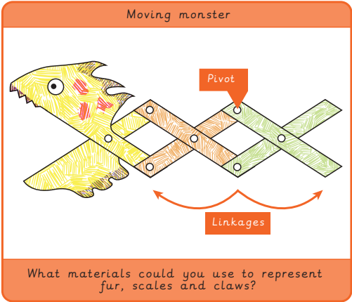 |  |   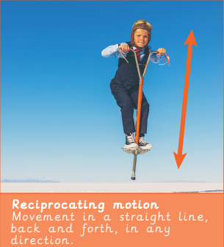  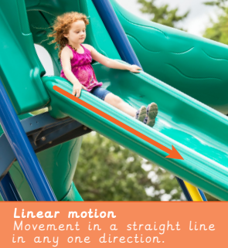  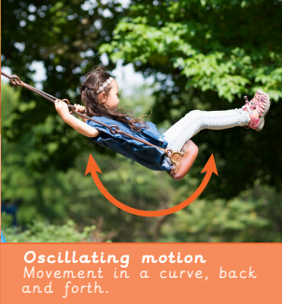  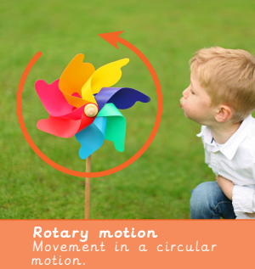 | Key words:  criteria A set of rules to help designers focus their ideas.  evaluation When you look at the good and bad points of something and see how you can improve it.  input The energy that is used to start something moving.  linkage Lengths of material that are joined together by pivots, so the links can move as part of a mechanism.  mechanical Something that can move because several pieces work together like a machine.  mechanism A collection of parts that work together to create a movement, eg. bicycle  moving Changing position.  output Output is the motion that happens as a result of starting the input.  pivot The central point, pin or shaft on which a mechanism turns or swings.  wheel A circular object that turns round.  .  Real life: End results!  