 | DT: Food – Wraps
 | Year Group: 2 | Subject Focus: DT | Term: Summer 2
We will learn:  - That ‘diet’ means the food and drink that a person or animal usually eats.  - What makes a balanced diet.  - The five main food groups: carbohydrates, fruits and vegetables, protein, dairy and oils and spreads.  - That I should eat a range of different foods from each food group, and roughly how much of each food group.  - That ‘ingredients’ means the items in a mixture or recipe.  - How to cut, grate, snip and spread to prepare foods.  - How to review and give a score to evaluate.  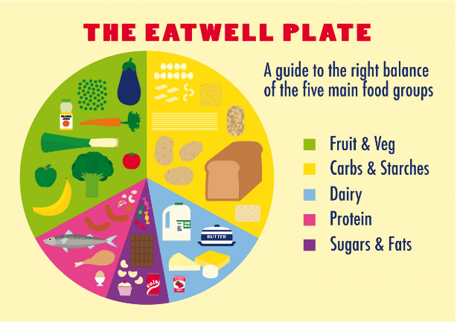 |  | Our learning journey:  - Name the main food groups and identify foods that belong to each group.  - Describe the taste, feel and smell of a given food.  - Think of different wrap ideas, considering flavour combinations.  - Construct a wrap that meets the design brief and our plans.  Key skills we will learn:  - Chopping foods safely to make a wrap.  - Grating foods to make a wrap.  - Snipping smaller foods instead of cutting.  - Spreading soft foods to make a wrap.  - Identifying the five food groups.  - Learning about a balanced diet.  - Tasting and evaluating different food combinations.  - Describing appearance, smell and taste.  - Designing three wrap ideas.  Useful links:  https://www.bbc.co.uk/bitesize/articles/zppvv4j  https://www.youtube.com/watch?v=YimuIdEZSNY  https://www.youtube.com/watch?v=C1SDXOP6Fbc | Key words:  balanced The right amount of things.  ingredients The different items in a mixture or recipe.  diet The food and drink that a person or animal usually eats.  dairy A food group that is made from animal milk. Dairy contains calcium which helps our bones and teeth develop.  carbohydrates A food group that gives us energy.  grater A tool that cuts food into small pieces.  protein A food group that helps us grow and develop.  combination A mix of different things.  table knife A slightly less sharp knife that is used mainly for spreading food or cutting cooked food.  design A plan to show how something is going to look.  .  Real life: End results!  