Dear Parent or Carer,  We hope that you have had a restful summer break and that your child is looking forward to returning back. I am looking forward to welcoming the children into Year 2 and beginning a brand-new school year. This half term our study unit is going to be a Geography focus, looking particularly at making Maps. The Knowledge Organiser will give you more details of the things we will learn. If you or your child have any interesting books, artefacts or photographs to do with the topic, please send them in to share.  English  Our Year 2 class author is Anthony Browne! In English, we will be reading Anthony Browne’s famous book Willy the Wimp to use as a stimulus in order to write with a focus to entertain. The children will be innovating a familiar story. We will focus on structure and the children will aim to write with a clear beginning, middle, end. The children will also be writing a non-chronological report about Nicola Adams. This links into our Science and PSHE learning which is all about physical health, well-being and what we need to keep healthy.  Maths  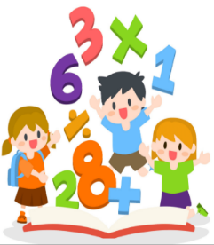  Our Maths learning this term will focus on Place Value. The children will be using place value charts in order to work with numbers up to 100. This will include partitioning numbers to 100, counting in 10s to 100 and comparing and ordering numbers to 100. | Homework  Reading  Please help us by returning reading books every Thursday to ensure that we can send out two new books each Friday.  Please comment on each book that your child reads, as when they achieve ten comments, they will receive a special certificate in Gold Book assembly as part of the ‘Ten Book Challenge’.  Spelling  Spelling sheets are given out alongside two reading books every Friday, to be returned the following Friday. Your child will have a short ‘Spelling quiz’ each week and we will communicate their results with you via their spelling sheet. Please encourage your child to practise their spellings little and often throughout the week.  Maths  Please encourage your child to play on Numbots regularly at home. Little and often is the perfect approach and will really support your child in learning their key number facts.  Your child’s log-in details for Numbots are on the inside cover of their reading records. Each week, a Numbots star is chosen for a special certificate in Celebration Assembly! If you have any difficulties logging on, please come and see me.  The children will be focusing on their 2 times-tables this half term. | Key dates  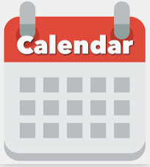  Tuesday 5th September 2023- Return to school.  There are currently no further key dates.  PE days  PE days are Tuesdays and Thursdays. Children should come to school wearing full PE kit on these days. If your child wears earrings, please make sure that they are taken out or covered before school on these days. If your child is unable to take part in PE, please could you let me know, this needs to be accompanied with a letter explaining why.  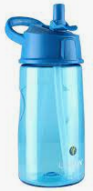  Reminders  Please remember to bring a named water bottle in to school each day.  Please ensure that all clothing is labelled with your child’s name.

